

**Master’s thesis**

Master's degree programme in Environmental Sciences

**Autarkic or import-dependent: How self-sufficient can Europe be in a future clean electricity supply and demand system on different administrative levels?**

Supervisor: Dr. Tim Tröndle

Swiss Federal Institute of Technology in Zürich,

Department of Environmental Systems Science,

Climate Policy Laboratory

Co-supervisor: Dr. Bryn Pickering

Swiss Federal Institute of Technology in Zürich,

Department of Environmental Systems Science,

Climate Policy Laboratory

Hongyu Chen

(21-945-332)

26 February 2023

Content

Abstract 1

1. Introduction 2

2. Literature review 5

3. Methods and data 10

3.1 Definition of administrative levels 10

3.2 Clean electricity supply potential 10

3.2.1 Onshore wind power 10

3.2.2 Offshore wind power 11

3.2.3 Open-field solar PV 12

3.2.4 Rooftop solar PV 13

3.2.5 Hydropower, nuclear power and geothermal 14

3.2.6 Biomass power 15

3.3 Future electricity demand 17

3.3.1 Transport sector 17

3.3.2 Industry sector 19

3.3.3 Building sector 20

4. Results 24

5. Discussion and Conclusions 32

5.1 National energy policy implications 32

5.2 Uncertainties and future research 41

6. Appendix 42

7. Acknowledgement 62

8. Reference 63

**Abstract**

In a future energy supply and demand system using clean electricity, many areas In Europe may have the possibility to achieve energy autarky with their own natural endowment. This study estimates how self-sufficient Europe can be in a future clean electricity supply and demand system on all administrative levels, from municipal, regional, national to the continental level. For each administrative unit, its annual electricity supply from clean sources and annual electricity demand with large-scale electrification are assessed to calculate the annual electricity balance. This study includes onshore wind, offshore wind, open-field solar PV, rooftop solar PV, hydropower, nuclear, geothermal and biomass power as clean electricity suppliers; meanwhile, the annual electricity demand in a certain administrative unit is summarized by assuming full deployment of air-source electric heat pumps in the building sector, massive use of battery electric vehicles in the transport sector, as well as large-scale direct electrification in other energy uses. Energy autarky is only seen as possible when the annual potentials of clean electricity exceed predicted local demand. The results show that even in the presence of a significant increase in future electricity demand, clean energy autarky is still highly feasible on the continental level. As the administrative hierarchy decreases, however, the percentage of energy-autarkic administrative units gradually decreases. Countries in central Europe, as well as some densely populated or economically developed areas are often unable to realize clean energy autarky. But for the Nordic countries, Iberia and the Balkans, their clean energy surplus is often plentiful and they are well positioned to become electricity exporters in the future. Clean energy autarky is also more feasible on sub-national levels in these areas.

1. **Introduction**

To achieve carbon neutrality, energy consumption must be decoupled from carbon emissions[1]. But this transition requires not only a switch to clean energy sources but also a fundamental restructuring of our energy supply and demand system. Since while providing us with energy, fossil fuels have also shaped the way we use them and become more and more locked-in over time[2]. The uses of fossil fuels in today's society can be summarized into three categories: energy use, where the energy stored in the material carriers like coal, oil and gas is released and converted to electrical or internal energy; motive use, where the energy is converted to mechanical energy and does work, which is common in the transport sector like vehicle engines; raw material use, where the fossil fuels themselves are used as material feedstock to produce products, which is most frequently seen in the chemical industry, like the production of plastics. Therefore, existing technologies that utilize fossil fuels cannot be easily substituted unless the demands that fossil fuels cover can also be satisfied with clean technologies that are cheaper and more available.

The maturation of many cleaning technologies now makes this substitution possible. First, renewable energy has gradually become cheaper than fossil energy. According to a report by IRENA[3], the global weighted average levelized cost of electricity (LCOE) of newly commissioned utility-scale solar PV projects declined by 88% between 2010 and 2021, whilst that of onshore wind fell by 68%, offshore wind by 60% and bioenergy by 14%. In 2021, the LCOE of the aforementioned renewables ranged from 0.033 to 0.075 USD/kWh. Compared with the LCOE range of fossil fuels, around 0.05 - 0.16 USD/kWh, renewable energy already has strong economic competitiveness. It can be expected that as the cost of renewable electricity travels down the learning curve, it is only a matter of time before its LCOE becomes completely lower than that of fossil fuels[4]. Second, many technologies that utilize clean energy can already replace the functions of fossil energy. For example, in the transport sector, BEV (battery electric vehicles) and electrified railways are replacing conventional fuel vehicles and diesel trains[5][6]; in the building sector, air-source heat pumps stand out as promising suppliers for space heat and water heat in houses[7]. With the decarbonization of the electricity supply and the electrification of the electricity demand, we can gradually decouple energy consumption from carbon emissions.

Along with new energy sources replacing old ones, the geographical pattern of energy flows will also change. Many studies agree that wind and solar power will replace fossil fuels as the main electricity suppliers in the future[8][9]. And these two electricity sources, rather than sourcing energy from material stocks with high energy density like fossil energy, are intercepted from transient and low-density energy flows in nature, with an uneven spatial distribution and high temporal intermittency. These features make the layout of a new electricity supply system more distributed, meanwhile enabling some areas originally dependent on imported energy to become self-sufficient with their local natural endowment. Now the possibility of energy autarky is hotly discussed in the current energy narratives in Europe, especially in view of the undergoing energy crisis[10][11][12].

Despite the possibility of clean energy autarky, there is no consensus on whether this goal should be pursued and at what administrative level a self-sufficient energy system should be established in the future. As renewable energy is mostly distributed through electricity[13], in a world mostly powered by renewables, the focus of energy autarky should be electricity autarky.

The supportive voices of electricity autarky may emphasize the risks of interconnection, as the supply side of an interconnected grid often has a natural advantage over the consumer side. When conflicts exist between the energy trading parties, the supplier may use power cut-off as a negotiating tool[14][15]; even some non-anthropogenic disruptions to the grid like outage can also affect more grid participants[16]. In economic aspects, high reliance on non-self-produced electricity will unavoidably force the purchasers to spend more trade surplus on importing electricity, thus causing an outflow of capital from local[17]; while local electricity production may increase local investment and employment[18][19], as well as enhance community awareness and create more positive links with renewable energy among local residents[20]. Importantly, realizing electricity autarky is also an effective way of securing energy supply in remote or rural areas[21][22].

The opposing voices often point out the potentially higher electricity tariffs and lower stability of small-scale grids, while a large-scale interconnected grid tends to be more resilient facing the intermittency of renewables and more cost-effective than isolated local grids[23][24]. Cross-border electricity trade can also intensify regional cooperation, creating “grid communities” and benefiting all grid participants[25][26]. In contrast, small-scale electricity autarky tends to be more expensive[23], and may lead to a large land footprint for electricity generation, which can cause land use conflict with local food and feed production or other land uses[27]. There are also political concerns that local electricity autonomy could weaken the control of the central government. The tax system and government revenues could be negatively impacted if electricity consumers were to use local grids. Moreover, if lower administrative units are able to satisfy their own energy needs independently of the central government, more radical political reforms could be demanded from the local[28]. Meanwhile, there are also opinions advocating for a “smart grid” to combine the benefits of energy autarky and large-scale interconnectivity[29][30][31].

Despite the ongoing debate, a prerequisite for electricity autarky in a certain administrative unit is that the local electricity supply exceeds the demand. Therefore, to identify whether clean electricity autarky is at all possible in Europe, we need to assess the clean electricity supply potential and demand for each relevant administrative unit. Some studies have examined the possibility of Europe becoming energy autarkic using selected kinds of renewable electricity supply technologies[32][33], with more research only assessing the supply potential of one or several renewable electricity sources[34]-[38], while currently, no study has been found that encompasses all the promising clean electricity supply and utilization technologies in a single consistent framework to examine the electricity autarky on all administrative levels in Europe.

This study seeks to close this gap by taking into account all the promising clean electricity supply and utilization technologies to examine the potential self-sufficiency level for each administrative unit in Europe. The goal is to answer the question of how self-sufficient Europe can be in a future clean electricity supply and demand system on all administrative levels. For this purpose, the annual potential of clean electricity supply technologies will be assessed in each administrative unit from municipal, regional (first-level sub-national administrative division), national to continental level (the European level); and then compared with the estimated local electricity demand using promising clean electricity utilization technologies. In the model of this study, clean electricity supply technologies comprise of nuclear electricity and renewable electricity, including onshore wind power, offshore wind power, open-field solar PV, rooftop solar PV, hydropower, geothermal power and biomass power. In the meantime, most of the energy demands of the building, transport and industry sectors in the model are electrified and assumed to be covered by air-source electric heat pumps, electric engines, hydrogen fuel cells and direct electrification. Finally, the annual electricity account for each unit is estimated by subtracting supply from demand. The geographic scope of this study comprises EU-28 countries without Malta, the Western Balkan countries including Albania, Bosnia and Herzegovina, Montenegro, North Macedonia and Serbia, plus Switzerland and Norway , in total 34 national units.

1. **Literature review**

Two studies assess the supply potential and demand of clean electricity on multiple administrative levels in Europe within a single consistent analysis framework. Tim Tröndle et al.[39] investigate the extent to which electricity autarky is possible on different administrative levels in Europe, from municipal to regional, national and continental levels. Administrative units where total renewable electricity potential is larger than demand are seen as electricity autarkic. Their model uses three steps to estimate the total electricity supply potential for each administrative unit. Firstly, surface eligibility analysis is conducted for each type of renewable energy to select suitable areas for wind and solar power installations, considering land cover, settlements, elevation, and protected areas, etc. Secondly, they use renewables.ninja simulation tool[40][41] to estimate the average capacity factor of different renewables on related areas. Finally, the installed capacity of different renewables in each administrative unit is estimated based on suitable areas, and combined with capacity factors to calculate the annual generation for each renewable. The total annual electricity generation of each administrative unit can be obtained by aggregating the results of each renewable. Their results show that electricity autarky is highly possible on the national and continental level. But the situation is different for sub-national administrative units: here, demand exceeds potential in several regions and municipalities, and the higher the population density, the greater the impact of this. Therefore, electricity autarky below the national level is often not possible in densely populated areas in Europe. Although this study only considers wind and solar PV on the supply side, and doesn’t assume future electricity demand scenarios, according to their findings, however, the supply potential exceeds demand in most administrative units. For example, the technical potential in Switzerland exceeds demand five times, and it is 400 times higher than the national demand in Latvia[39]. This leads one to speculate that electricity autarky may still be possible after considering additional electricity sources and future patterns of electricity demand.

Bryn Pickering et al.[42] confirm the possibility of energy autarky in Europe with many cost-effective technology options. They develop a high-resolution model of the entire European energy supply and demand system on continental, national and regional levels. For energy supply technologies, their model includes wind power, solar PV, hydropower, nuclear power, bioenergy and solid waste power. Meanwhile, the energy demand is divided into four sectors: building heat, electricity, synthetic fuel and road vehicle mileage. The results show that a wide range of systems based on renewable energy is feasible, with no need to import energy from outside Europe. In their study, the estimated sector-coupled energy service demand is up to 2.61 - 2.85 times higher than the actual electricity demand in 2018[42].

Although no direct results are given, the Hotmaps Project[43] provides a large array of open datasets about renewable electricity and heat supply and demand on different administrative levels for European countries. On the supply side, Hotmaps can estimate the annual electricity or heat supply of wind, solar, geothermal and biomass as well as district heat and excess heat from industry on all administrative levels in Europe. On the demand side, the annual heat demand for industry, residential and tertiary sectors are aggregated on each administrative level. Hourly load profiles are also provided on the regional level for the residential, tertiary, and industry sectors.

Combining the dataset with the most complete dataset found so far, i.e., the annual supply potential of onshore wind, offshore wind, open-field solar PV and rooftop solar PV from Tim Tröndle et al.[39], and biomass including agricultural residues, forestry residues and solid wastes from the Hotmaps Project[43]; we can compare the renewables potential with current energy demand, as Figure 1 shows. Each number pair in the figure represents the national renewables potential relative to electricity demand in 2021 and the national renewables potential relative to primary energy demand in 2021 respectively. Based on the data shown in the figure, all the countries are able to cover their current national electricity demand with their own renewable electricity potentials, while only 56% (19 out of 34 countries) of the studied countries have higher renewable electricity potentials than their own primary energy consumption. As it is expected that most energy uses will be electrified in the future since renewable energy is mostly distributed through electricity[13], and electrification is typically more efficient than fuel combustion as in the case of electric engines and electric heat pumps, the actual primary energy consumption may be lower than current consumption if other things being equal. It can be seen from Figure 1, however, that electricity autarky may not be feasible in some countries when massive electrification of energy uses is taken into account.

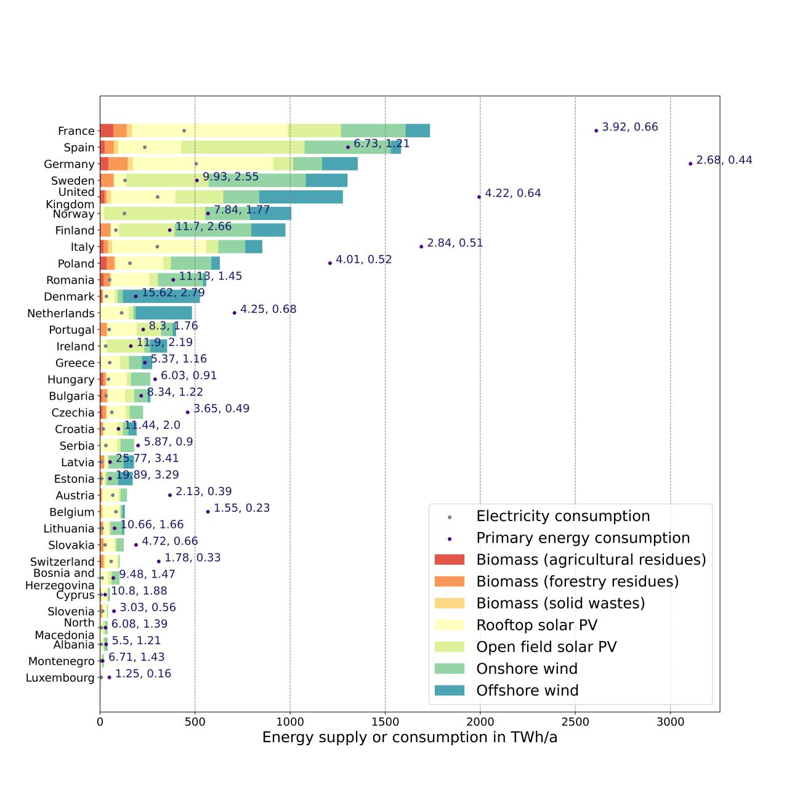

Figure 1 Renewable energy supply potential and current demand

Except for the three above-mentioned research, no studies assessing energy potentials in the context of energy autarky on all administrative levels in Europe have been found, but some studies estimate the total theoretical potentials of certain clean energy supply technologies in Europe. Due to drastically different assumptions, even the results for the same technology vary significantly. The scope of most of the studies is the European continental, while some countries such as Germany and Switzerland are also frequently studied[44]-[48]. But energy potential studies on subnational levels is relatively rarer.

The most frequently studied clean electricity source on the continental level is onshore wind, with estimated potentials varying from 4.4 PWh/a[49], 8.4 PWh/a[50], 20 PWh/a[51], 34.3 PWh/a[52] to 39 PWh/a[53] in Europe. This strong variation can be explained by their different land eligibility criteria, unit capacity per turbine, and unit of power generation (Some studies are in units of power generation per unit area, others are in units of power generation per turbine, and the distribution of each turbine is bounded by specific geometric rules). For offshore wind, four research has been found with an estimated annual generation potential of 1.3 PWh[50], 3.4 PWh[53], 13 PWh[54] and 16.2 PWh[55] in Europe, respectively, of which the huge gap is mainly due to different water cover eligibility and assumed turbine parameters like unit capacity per turbine and distance between turbines. For rooftop solar PV potential in Europe, results differ from 0.68 PWh/a[56], 0.84 PWh/a[57] to 1.5 PWh/a[58]. One study also gives the reference range of 1.2 - 2.1PWh/a[58]. The difference in results can be explained by different geographical scopes and assumed solar PV panel parameters. For open-field solar PV, one analysis gives the reference value of 11 PWh/a[50]. Compared with Europe's current electricity demand of around 3 PWh/a, the possibility of clean electricity autarky looks promising on the continental level when the current electricity consumption level is assumed.

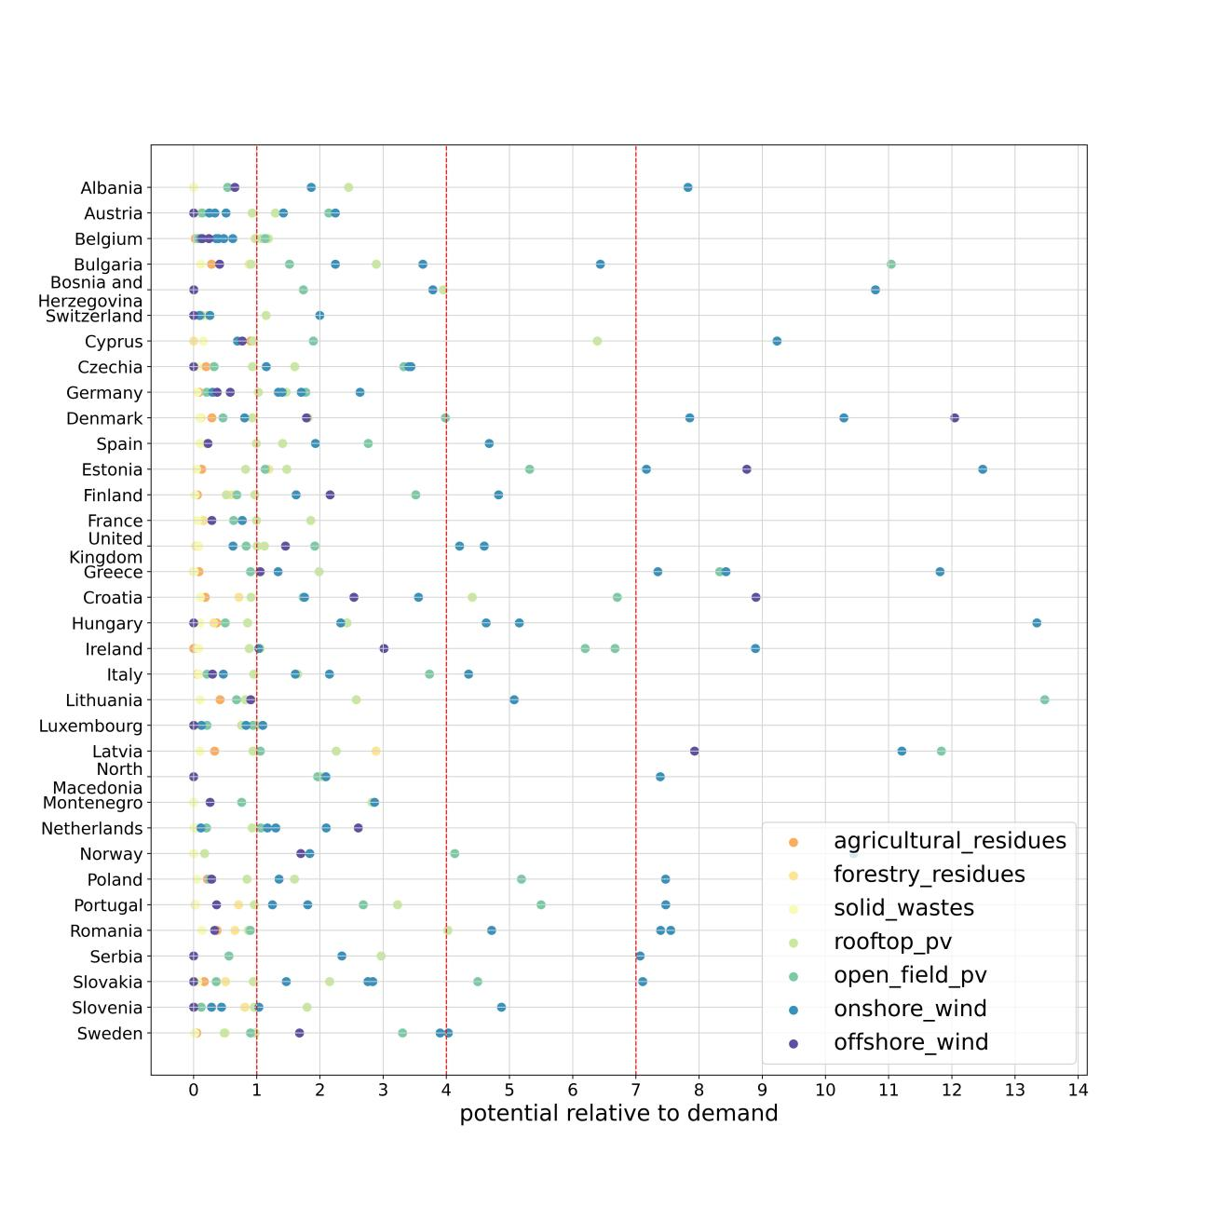

Figure 2 National potential relative to demand of individual renewables

On the national level, many studies estimating the supply potential of one or several renewables have been found[49]-[68], as Figure 2 shows. Although the assumptions and scopes of these studies vary considerably between models, making the estimated potentials differ greatly from each other with the difference in the order of magnitude of about 1 to 10 times, it can be seen from Figure 2 that meeting current electricity demand with renewables is very optimistic. However, since primary energy demand is usually 4 to 7 times as large as electricity demand, electricity autarky on the national level after large-scale electrification becomes less optimistic. On the regional and municipal levels, there are some studies which assess the supply potential of wind or solar PV[69]-[73], but their analytical frameworks haven’t been extended to more regions or municipalities.

Except for wind and solar power, which are considered the main electricity sources for the future grid to reach carbon-neutrality[8][9], hydropower, nuclear power and biomass power are also seen as supplements to the future electricity system. But the future development of these energy sources in Europe is not generally favoured. For hydropower, the increase in annual power output will be less than 10% even after modernization of existing facilities[74]. Besides, the development of hydropower inevitably has an impact on the water ecosystem and may potentially affect certain species[75], which could incur criticism and opposition from voices that emphasize on the environment[76][77]. For nuclear power, as many countries are planning to phase it out, its generation share is expected to decline gradually in the future[78], but nuclear will still contribute to the transition process towards carbon neutrality. Biomass energy is often criticized for its low energy density and potential conflict with food and feed production[79], but the utilization of agricultural and forestry residue and solid waste is still promising. The application of deep geothermal power in Europe is rather restricted mainly in Iceland and a few other regions that display volcanic activity[80]. The development of the ocean power in Europe is constrained by its immature technology and lack of funding[81]. According to the data from ENTSOE-E transparency platform, no ocean power plants are delivering electricity to the grid[82]. Therefore, it is expected that the current generation pattern of hydropower, nuclear power and geothermal power will not grow substantially in the future; while biomass power using “waste materials” can gain momentum and serve as a supplementary energy source.

1. **Methods and data**

The possibility of electricity autarky in Europe is examined on four administrative levels: continental, national, regional and municipal. For each administrative unit, its clean electricity supply potential and future electricity demand are quantified on an annual basis. Only units where annual electricity supply potential exceeds annual demand are seen as autarkic. All data sources used in the analysis are listed in the Table 1 in this study.

* 1. Definition of administrative levels

The geoBoundaries database[83] is used to identify the administrative units as well as their geographic shapes on the four levels. The continental level is the entire scope of this study, which is EU-28 excluding Malta, the Western Balkans countries Albania, Bosnia and Herzegovina, Macedonia, Montenegro, and Serbia, plus Switzerland and Norway, in total 34 countries. Individually, those countries form the national level and their geographic shapes are given by ADM (administrative level) 0 data in the geoBoundaries database. The regional level is defined as the first-level sub-national administrative divisions, For example, cantons in Switzerland or Bundesland in Germany, of which the geographic shapes are given by their respective national geoBoundaries ADM 1 data. For the municipal level, the lowest ADM levels in geoBoundaries database of each country are adopted, For example, ADM 5 for France, ADM 4 for Belgium and ADM 3 for Germany. Among them, the municipal level of Montenegro is also ADM 1 since no lower levels can be found. Besides, the overseas territories of France and the United Kingdom, as well as Atlantic islands West of 15°W are excluded from the scope since their electricity autarky is not linked to the European continent. In sum, there are 179559 municipal units, 518 regional units, 34 national units and 1 continental unit. Each unit is assigned a unique number as an index in the form: {three-letter-country-code}-{ADM level}-{number}. For example, the index of one municipality in Germany could be DEU-ADM3-1, the index of one region in France could be FRA-ADM1-10.

* 1. Clean electricity supply potential

This study examines the potential clean electricity supply technologies that may form the future fleet of electricity suppliers, including onshore wind power, offshore wind power, open-field solar PV, rooftop solar PV, hydropower, nuclear power, biomass power and geothermal. It is assumed that all the traditional power plants using fossil fuels are decommissioned while all the electricity demands are covered by the clean electricity suppliers mentioned above. In the analysis, the annual generation potential of each supplier is estimated for each administrative unit on all levels.

* + 1. Onshore wind power

The estimation of onshore wind power potential has three steps: excluding unsuitable land areas and determining potential turbine locations, calculating and assigning annual average capacity factor to each turbine, and summarizing the annual generation of onshore wind turbines in each administrative unit.

The GLAES eligibility tool[84] is used to determine the eligible locations for installing onshore wind turbines, with the applied exclusion criteria listed in Table 2 in the appendix. The prior datasets in GLAES are used in actual computation and their original sources are also marked in Table 2. After obtaining the eligible land areas, the placement function in GLAES is used to determine the potential wind turbine locations. According to IRENA, today’s new wind power projects have a turbine capacity in the 3 - 4 MW range onshore[85]; here the optimistic value 4 MW is adopted. The Vestas V150-4.2 MW is chosen as the representative turbine type[86], assuming a minimum distance between turbines to be five times of the turbine diameter, and the distance between onshore turbines in the study is set to be 750 m. In actual modeling, the geographic scope for each round of calculation is only one region to lighten the memory load; after repeating the same procedure for each region, the exact coordinate of each eligible onshore wind turbine in the continent can be obtained.

To determine the capacity factor of each onshore wind turbine, one existing dataset from renewables.ninja simulation is adopted[87]. This spatio-temporal dataset contains capacity factors time series for locations on a grid with a 50 km edge length in Europe. The data is resolved in one-hour time-steps and comprises the years 2000 - 2018. An annual average capacity factor can be calculated for each existing simulation point; afterwards, the average capacity factor of the nearest existing simulation point is assigned to each onshore wind turbine. In the next step, the administrative belongings are attributed to each onshore wind turbine according to its geographic coordinate. Finally, the annual generation from onshore wind in each administrative unit can be calculated with the following equation:

Here stands for the annual generation of onshore wind power in a certain administrative unit. is the number of onshore wind turbines in the administrative unit. is the installed capacity of one onshore wind turbine, in this analysis, the value is assumed to be 4 MW. *h* is the total hour amount in a year, which is 8760 h/a. is the annual average capacity factor.

* + 1. Offshore wind power

The estimation of offshore wind power potential follows a similar procedure as onshore wind power, but with two major differences. First, different capacity per turbine and turbine distance are adopted. According to IRENA, today’s new wind power projects have a turbine capacity in the 8 - 12 MW range offshore[88], here the optimistic value 12 MW is adopted. The GE Haliade-X offshore wind turbine is chosen as the representative turbine type[89], assuming a minimum distance between turbines to be about seven times the turbine diameter, and the distance between offshore turbines in the study is set to be 1500 m. Other adopted parameters are listed in Table 3 in the appendix with the data source. In actual modeling, the geographic scope for each round of calculation is the EEZ (exclusive economic zone) of each coastal country; after repeating the same procedure for each coastal country, the exact coordinate of each eligible offshore wind turbine in the continent can be obtained. Then, applying a similar method as for the onshore wind power, the capacity factor of existing renewables.ninja simulation points are attributed to each offshore wind turbine.

Second, a different attributing method to administrative unit on subnational levels are used. For the administrative belongings on the national level, offshore turbines that are located in the EEZ of a certain country are assumed to belong to this country; while on the subnational levels, it is assumed that each turbine belongs to the nearest administrative unit on land. Finally, the annual generation from offshore wind in each administrative unit can be calculated with the following equation:

Here stands for the annual generation of onshore wind power in a certain administrative unit. is the number of offshore wind turbines belonging to the administrative unit. is the installed capacity of one onshore wind turbine, in this analysis, the value is assumed to be 4 MW. *h* is the total hour amount in a year, which is 8760 h/a. is the annual average capacity factor.

* + 1. Open-field solar PV

The estimation of open-field solar PV potential can be divided into three steps: selecting and calculating suitable land areas, calculating and assigning annual average capacity factor to land, and summarizing annual generation of open-field solar PV in each administrative unit. The GLAES eligibility tool[84] is used to determine the eligible land areas for placing open-field solar PV panels, with the applied exclusion criteria listed in Table 4 in the appendix. The prior datasets in GLAES are used and their original sources are also marked in Table 4. In actual modeling, the geographic scope for each round of calculation is only one region to lighten the memory load; after repeating the same procedure for each region, a raster file can be obtained containing the eligible areas in each region.

In the second step, capacity factors are attributed to the eligible areas obtained in the last step. To do this, the existing dataset from renewables.ninja simulation is adopted[87]. An annual average capacity factor can be calculated for each existing simulation point; afterwards, a voronoi diagram is generated based on all the existing simulation points. In this way, the original points are extended to polygons where any point within the polygon is closer to its own polygon centroid (the original point) than other polygon centroids. Then, the newly created voronoi diagram is clipped to the extent of each municipality unit. The purpose of this method is to split municipalities into areas that may have different average annual capacity factors. This is in fact the same principle as for determining the capacity factor for wind power, namely the nearest principle; each point or area adopts the capacity factor of its nearest existing simulation point. After this procedure, a more subdivided geographic pattern is formed, but the administrative belonging and capacity factor is homogeneous within each cell.

In the last step, the zonal statistics operation is conducted by calculating the area of eligible places in each sub-municipal cell obtained in the last step. To calculate the total eligible area and total average capacity factor within each municipality, a weighted average capacity factor is calculated with the eligible area as the weighting. In this way, the sub-municipal cells are aggregated back to municipal units with their total suitable areas and annual average capacity factors. Finally, the annual generation from open-field solar PV in each municipal unit can be calculated with the following equation:

Here stands for the annual generation of open-field solar PV in a certain municipal unit. is the area of eligible lands in the administrative unit in hectare. is the capacity density of open-field solar PV panels, in this analysis, the value is assumed to be 0.8 MW/ha[32]. *h* is the total hour amount in a year, which is 8760 h/a. is the annual average capacity factor. The potential of higher administrative units can be calculated by summing up the values of their belonging municipalities.

* + 1. Rooftop solar PV

The estimation of rooftop solar PV potential follows a similar procedure as open-field solar PV, but with two major differences. First, instead of using the GLAES tool, it is assumed that all the existing rooftops in Europe can serve as primitive potential installation places; however, the primitive value should be multiplied by a ratio to settle the areas of actual usable rooftops. In this study, the ratio of the usable rooftops is set to be 0.56, which comes from a study by Tim Tröndle et al.[23]; while the rooftop rater datasets are from Copernicus[90] with 10 meters resolution. Second, considering that the orientation of the houses will affect the efficiency of installed solar PV panels, the ratio of houses to different directions must be taken into account. In the study by Tim Tröndle et al.[23], they use the 3D GIS data of Swiss buildings to estimate these ratios and adopt the values for the whole Europe. This study uses their results with West-and-East-oriented rooftops ratio as 0.334, North-oriented rooftops ratio as 0.182, and flat-and-South-oriented rooftops ratio as 0.484. With these ratios as weightings, the weighted average annual capacity factor of existing simulation points can be calculated.

Except for these two differences, the general calculation procedures are almost the same as open-field solar PV. Generally, a voronoi diagram is created for the existing simulation point, which is then clipped to the extent of each municipality, and zonal statistics operation is conducted to calculate the area of the eligible surface within each sub-municipal cell, which is then aggregated again to the municipal level. The annual generation from rooftop solar PV in each municipal unit is calculated with the following equation:

Here stands for the annual generation of rooftop solar PV in a certain municipal unit. is the area of rooftops in the administrative unit in hectare. is the ratio of usable rooftop. is the capacity density of rooftop solar PV panels, in this analysis the value is assumed to be 0.8 MW/ha[23]. *h* is the total hour amount in a year, which is 8760 h/a. , , are the annual average capacity factors for rooftops facing South or flat, facing West or East, and facing North respectively, while , , are their respective ratios. The rooftop solar PV potential of higher administrative units can be calculated by summing up the values of their belonging municipalities.

* + 1. Hydropower, nuclear power and geothermal

For hydropower, nuclear power and geothermal generation, it is assumed that the current generation pattern will remain unchanged in future. To calculate the annual generation from these three technologies on each administrative level, this study uses the actual generation data and power plant net energy surplus to pinpoint the annual average generation of hydropower plants, nuclear power plants and geothermal power plants in Europe. Except for Albania, the actual generation data per hour from the year 2015 can be obtained from ENTSOE-E Transparency Platform[91], while the actual generation data of Albania can be accessed from their national official database[92]. The power plant net energy surplus can be downloaded from the website of the World Resources Institute[93], with detailed information such as geographic coordinates and installed capacity of power plants of each type. In this part, two assumptions are made. First, it is assumed that the historical average annual generation of hydropower, nuclear power and geothermal can represent their annual generation in future. Second, this study assumes that, for the same type of generation technology, its national annual generation is distributed among this type of power plant across this country with the installed capacity as the weighting.

For example, if the historical annual average generation of hydropower in a certain country is 10,000 MWh per year, and this country has two hydropower plants with installed capacity 6 MW and 4 MW, then according to the assumptions mentioned above, the annual generation of these two power plants would be 6,000 MWh and 4,000 MWh respectively. With the geographic coordinates of the power plants, their annual generation can be accurately attributed to their belonging regions or municipalities.

* + 1. Biomass power

This study doesn’t consider scenarios where certain parts of the land are dedicated to biomass production and further generation of electricity since its low energy density and potential conflict with food and feed production[79]. However, the utilization of agricultural and forestry residue and solid wastes is still promising. In this study, these three types of biomass are assumed as fuels for electricity generation with 40% efficiency.

For agricultural residues, this study considers the harvesting residues for eight kinds of crops in Europe (wheat, rye, barley, oats, maize, rape, sunflower, and rice) and the pruning residues for three kinds of agricultural plants (fruits and berries, vineyards and olives). The annual electricity generation from agricultural residues in a certain municipal unit can be calculated with the following equation:

Here stands for the annual electricity generation from agricultural biomass in a certain municipal unit. means the national annual production of the corresponding crop, which can be retrieved from Eurostats[94]. is the total planting area of residue type i in the whole country; while is the total planting area of residue type i in the studied municipality. As there’s no direct data, the pixel amount of certain values in CORINE Land Cover Database 2018[95] are used as proxy to substitute area, which is calculated by conducting zonal statistics operation. Applied pixel values with their affiliated land cover types are listed in Table 5. i stands for the index of agricultural residue types, in total there are 11 types. is the energy density of residue type i in MWh/t. is the residue-to-yield ratio of residue type i, which tells how many units of residues are produced when one unit of product is harvested; is the remaining rates, which describes the ratio of residues that can actually leave the land, since some shares of residues should be remained in land to maintain fertility or for other purposes; is the actual use rate, since some of the residues are diverted into other usages like animal bedding and mushroom production. The adopted values of these parameters are listed in Table 6 in the appendix. is the energy conversion ratio, which is set to be 40% in this study. After obtaining the municipal results, the potential of higher administrative units can be calculated by summing up the values of their belonging municipalities.

For forestry residues, this study considers the logging and processing residues of round woods, and existing fuel wood products that are dedicated to electricity generation. The annual electricity generation from agricultural residues in a certain administrative unit can be calculated with the following equation:

Here stands for the annual electricity generation from agricultural biomass in a certain municipal unit. and means the national annual production of round wood and fuel wood respectively, which can be retrieved from Eurostats[94]. is the total forestry area in the whole country; while is the forestry area in the studied municipality. Again, the pixel amount of certain values in CORINE Land Cover Database 2018[95] are used as proxy to substitute area of certain land cover types, which is calculated by conducting zonal statistics operation. Applied pixel values with their affiliated land cover types are listed in Table 7 in the appendix. and is the energy density of round wood residues and fuel wood in MWh/t, in this study 4.38 and 5.25 are adopted for these two parameters respectively[96].is the residue-to-yield ratio of round wood, which tells how many units of logging or processing residues are produced when one unit of round wood is produced, here value 0.1 is assumed; is the actual use rate is round wood residues, which is assumed to be 0.3 in this study. is the energy conversion ratio, which is set to be 40% in this study. After obtaining the municipal results, the potential of higher administrative units can be calculated by summing up the values of their belonging municipalities.

For solid wastes, the annual electricity generation from solid wastes in a certain administrative unit can be calculated with the following equation:

Here stands for the annual electricity generation from solid wastes in a certain municipal unit. means the national annual generation of solar wastes, which can be retrieved from Eurostats[94]. is the population of the municipality; is the population in the whole country to which the municipality belongs, the pixel amount of certain values in JRC Population Database[97] are used as proxy to substitute solid wastes generation, which is calculated by conducting zonal statistics operation. is the energy density of solid wastes, here this study adopts the value 2.78 MWh/t[98]. is the actual use rate of solid wastes, here the value 0.1 is used. is the energy conversion ratio, which is set to be 40% in this study. After obtaining the municipal results, the potential of higher administrative units can be calculated by summing up the values of their belonging municipalities.

Finally, the total annual electricity generation in each administrative unit is obtained by:

The total annual electricity supply potential in each administrative unit is obtained by:

* 1. Future electricity demand

In line with the future electricity supply system discussed in the last chapter, we need to assume a future electricity demand system. Traditional fossil fuels that underpin today’s energy system have three main functionalities: energy use, motive use and raw material use. In this study, it is assumed that the energy use of fossil fuels is fully replaced by the aforementioned seven clean energy suppliers; while its motive use is only partially substituted with clean energy suppliers, this study only assumes substitution in road and rail transport; but the current raw material use of fossil fuels remains unchanged.

* + 1. Transport sector

For road transport, it is assumed that except for heavy freight vehicles, all vehicles are replaced with BEV (battery electric vehicle); while hydrogen fuel cell vehicles are adopted for heavy freight transport, since the higher energy density of the hydrogen fuel cells makes it more suitable for heavy-duty vehicles. Here it is assumed that the hydrogen used for fuel cells are green hydrogen (hydrogen from electrolysis), the electricity consumption for which is also included in the local annual electricity demand net energy surplus. For rail transport, electrified railways as well as intra-city trams and metros have already accounted for a large share, while the rest is almost all taken up by diesel engine trains. In the model, this study fully replaces the diesel engines with electric engines to reach 100% electrification in the rail transport.

The energy demand in road transport can be divided into four types: private passenger transport, public passenger transport, light freight transport and heavy freight transport. Except for private passenger transport, this study adopts a top-down approach. For these three types of transport, diesel engine accounts for the vast majority in all studied countries (>90%). To simplify the calculation, the energy consumption of other types is all added to that of diesel engine, so that a uniform energy conversion ratio can be adopted. The annual electricity demand for each type of road transport except for private passenger transport in a certain municipality can be calculated with the following equation:

Here , , are the annual electricity demand of public passenger transport, light freight transport and heavy freight transport respectively; while , , are the original annual energy demands, which has direct data in the JRC-IDEES database[97] for EU countries. For non-EU countries, a regression is made between original annual energy demand and population for EU countries. The obtained parameters are shown in Table 8 in the appendix. Thus, the original annual energy demands can be estimated using the following equations. , , are the energy efficiency of diesel engine, electric engine and hydrogen fuel cell engine, this study adopts the value 0.5, 0.85 and 0.4 respectively.

For private passenger transport, a bottom-up approach is used with the following equation:

Here stands for the annual electricity demand of private passenger transport in a certain municipality. *P* is the population of the municipality, which can be calculated by conducting zonal statistics operation using JRC Population Database[99]. is the car ownership rate (number of cars owned/ person). is the annual mileage (km/car). is the electricity consumption per kilometer in kWh/km. After obtaining the municipal results, the potential of higher administrative units can be calculated by summing up the values of their belonging municipalities.

The annual electricity demand for the entire road transport equals:

For rail transport, the annual electricity demand is obtained by substitute the original diesel engine with electric engine using the equation:

is the annual electricity demand of the entire rail transport in the studied municipality; , , are the original annual electricity demand of metros and trams, electric trains and diesel trains respectively. For EU countries, these values can be directly retrieved from JRC-IDEES database[97], while a similar regression as for road transport is conducted for non-EU countries, for which the regression parameters are listed in Table 8.

Finally, the total annual electricity demand in the studied municipality in the transport sector can be calculated with the following equation. After obtaining the municipal results, the electricity demand of higher administrative units can be calculated by summing up the values of their belonging municipalities.

* + 1. Industry sector

As mentioned above, this study doesn’t assume substitution in the raw material and motive uses of current fossil fuels in the industry sector. For energy use, it is assumed that it is fully covered with resistive electric heat with 100 % efficiency. Here the method distinguishes between EU country and non-EU country, and divide the industry sector into energy-intensive industries and non-energy-intensive industries.

In this study, the energy-intensive industries are defined as large-scale point-source industrial energy consumers including iron and steel industry, non-ferrous metal industry, non-metallic-minerals industry, chemical industry and paper and pulp industry. The ETS dataset of EU countries has detailed documentation about the CO2 emission and emitter coordinates for each factory of the aforementioned industries[100]. Thus, for the same kind of industry, we can use its emission as the proxy for energy consumption. For example, if an iron factory emits 5% of the total national CO2 in the iron and steel industry, then according to the assumption above, its annual energy demand should also be 5% of the total national energy demand in the iron and steel industry. In this way, the national energy demand for each kind of the energy-intensive industry can be disaggregated to the municipal level.

However, no similar data has been found in other countries studied. For the energy demand of energy-intensive industries in non-EU countries and non-energy-intensive industries in all the countries studied, the population is used as the proxy for industrial energy demand. The electricity demand of the industrial sector at each municipality can be estimated with the following equation, and the electricity demand of higher administrative units can be calculated by summing up the values of their belonging municipalities.

* + 1. Building sector

The energy demand in the building sector can be divided into three parts: space heating, water heating and other appliances. This study assumes full electrification in all the building appliances. Among them, the air-source radiator heat pump is adopted to cover the full need of space heating; while the air-source water heat pump supplies all the heat for water heating; and the rest of the appliances will be directly powered by electricity. Since the efficiency of heat pumps is closely related to the temperature difference between the heat source and sink environment, we need to estimate the heat demand and heat pump COP (coefficient of performance) of each small time interval to calculate the annual electricity demand on heat pumps.

First, to calculate the actual COP of heat pumps, the methods from when2heat[101] are applied. For the air-source heat pump, the COP equals:

is a transient variable, but here the hourly average temperature is used instead to simplify the calculation. For air-source heat pumps, the ambient air temperature from the ERA-Interim dataset[102] is directly used as the source temperature ; while the sink temperature distinguishes between water heating and radiator space heating. The sink temperature of water heating is assumed to be 50℃ as a constant; while the sink temperature of space heating can an be calculated with the equation below.

Repeating the calculation for each existing ERA5 data point, the COP of water heat pumps and radiator space heat pumps can be obtained.

Second, the revised method from when2heat[101][103] are adopted to calculate the hourly heat demand. According to this method, the daily space () and water () heating demand factor are calculated as follows:

These demand factors can be interpreted as unscaled daily demand. is assumed as the weighted average of the daily average temperature of the past four days. with *= 40*. BDEW presents sets of profile function parameters, *A, B, C, D, mspace, bspace, mwater, bwater*, for various building types, namely single-family houses, multi-family houses, and commercial buildings, which are listed in Table 9 in the appendix. Besides, the local wind speed is related to which sets of parameters to choose. Therefore, for each day all locations are examined based on the averaged ERA-Interim wind speed data: for averages above 4.4 m/s, the parameters for “windy” locations is applied. Otherwise, the locations are assigned to the “normal” category. Besides, BDEW distinguishes SFH (single-family houses), MFH (multi-family houses) and COM (commercial houses), each one with its sets of daily demand function parameters. In this way, different kinds of space heating and water heating demand factors are calculated for each ERA point for each day throughout the year. In actual model, the daily average temperature and wind speed are calculated from year 2000 - 2018, which is for the consistency with the time span of capacity factors data in the wind and solar energy potential calculation. is a correcting parameter, which equals the difference between heating threshold function of the studied country and Germany[104]. Some studied countries don’t have direct data, therefore the heating threshold data of their neighboring country is adopted. All the applied heating threshold values are listed in Table 10 in the appendix.

In the next step, the daily demand factors are disaggregated to hourly resolution. BDEW provides hourly ratios for daily demand factors under different temperature. For different types of houses and different daily average temperature, the hourly ratios are also different. Hourly ratios for SFH, MFH and COM houses are listed in Table 11, Table 12 and Table 13 in the appendix respectively. Multiplying the daily demand factors with their respective hourly ratios, we can obtain the hourly demand factors, which are proportional to the actual daily heat demand. Then, for each type of building heat demand, its annual electricity demand can be calculated with the following equations.

Here is the annual electricity demand of a certain type of building heat demand. is the hourly heat demand ratio, which is calculated by dividing the hourly demand factor with the sum of all the factors in the year. is the hourly coefficient of performance of the heat pump. is the total annual heat demand. However, considering that there are three house types: SFH, MFH and COM; and two types of heat demand: space heating and water heating. The total electricity demand on building needs to be aggregated with the following equation.

Here stands for the total electricity demand in the building sector; are the electricity demand of space heating in SFH, space heating in MFH, space heating in COM, water heating in SFH, water heating in MFH, water heating in COM respectively. , , , , , are the respective hourly ratio; while and are the hourly coefficient of performance of radiator and water heat pump. is the ratio of single family houses. , , , are the annual residential space heating demand, commercial space heating demand, residential water heating demand, commercial water heating demand.

So far, for each geographic point in ERA-interim dataset, the above equations can be calculated. The next step is how to connect the above the existing ERA points with administrative unit. We can find in the aforementioned equations that all the are actually constants, therefore, the ratios , , , , , are also constant. Thus, a geojson file can be created where each point possesses its own six fixed aforementioned ratios. Once we know , , , , the can be extrapolated.

To connect municipalities with the data of existing points, the nearest principle is used again. In the model, each municipality adopts the six ratios of its nearest ERA point according to the distance between the centroid of the municipality shape and ERA point. Then, for EU countries, the national data of these four values can be directly retrieved from the JRC-IDEES datasets[97]. It is assumed here that building heat demands are proportional to population nationally and internationally, which is validated by conducting regression between national heating energy demand and national populations. The regression results are listed in Table 14 in the appendix.

Thus, with the population amount of each municipality, its annual electricity demand in the building sector can be estimated. Finally, the electricity demand in the building sector of higher administrative units can be calculated by summing up the values of their belonging municipalities.

In sum, the total electricity demand in a municipality equals:

1. **Results**

On the continental level, energy autarky is highly feasible. The total energy supply can reach 27.56 PWh/a, compared with the estimated total energy demand of 7.62 PWh/a, the potential relative to demand ratio is 3.62, leaving an energy surplus of 19.94 PWh/a. Among the energy suppliers, onshore wind power accounts for the largest share (46.55%) with open-field solar PV as the second largest source (26.97%), and offshore wind power as the third (15.44%). All the other clean electricity sources including rooftop solar PV, hydropower, nuclear power, biomass power and geothermal make up the rest 11.04%. For the energy demand, the industry, transport and building sectors constitute 41.74%, 29.45% and 28.81% of the total demand respectively. The estimated total electricity demand is 2.45 times the current electricity demand (2021), but only 41.35% of the current total primary energy consumption (2021) in Europe. These numbers support the point made earlier that massive electrification of energy uses under the clean energy system can significantly push up total electricity demand; however, but also reduce the total primary energy consumption compared to the current energy usage scenario using fossil fuels. The important numbers on the continental level are listed in Table 15 in the appendix.

On the national level, energy autarky is possible in 73.53% (25 out of 34) European countries with positive energy net energy surplus, but the situation is rather pessimistic for some countries located in central Europe. The estimated annual national energy supply, demand and net energy surplus are listed in Table 16 in the appendix, while the national net energy surplus data is also visualized in Figure 3 and Figure 4. As the figure and the table show, some countries in the center of Europe would have an energy deficit, such as Austria, Belgium, Czech Republic, Germany, Hungary, Slovenia, Slovakia and Switzerland; while countries on the periphery tend to have plenty of potentials, which implies that the countries with energy deficits will have to import energy from their nearby countries to reach energy self-sufficiency. This interconnection is also theoretically possible, since the net energy surplus is very adequate on the continental level as mentioned above. However, when considering redundancy, countries with large population may need to retain more of their energy potentials for their own use, since future economical or technological development will require higher electricity consumption, which is often related to population. Therefore, countries with energy deficit should consider to import energy from neighboring countries with high energy surplus and energy surplus per capita. As Figure 3 and Figure 4 shows, countries on the Iberian Peninsula, Balkan Peninsula and in Northern Europe have not only higher total energy surplus, but significantly higher energy surplus per capita than many central European countries. France and Italy have large amount of net energy surplus, but their energy surplus per capita is more modest, thus, they are not suitable for being large-scale energy exporters.

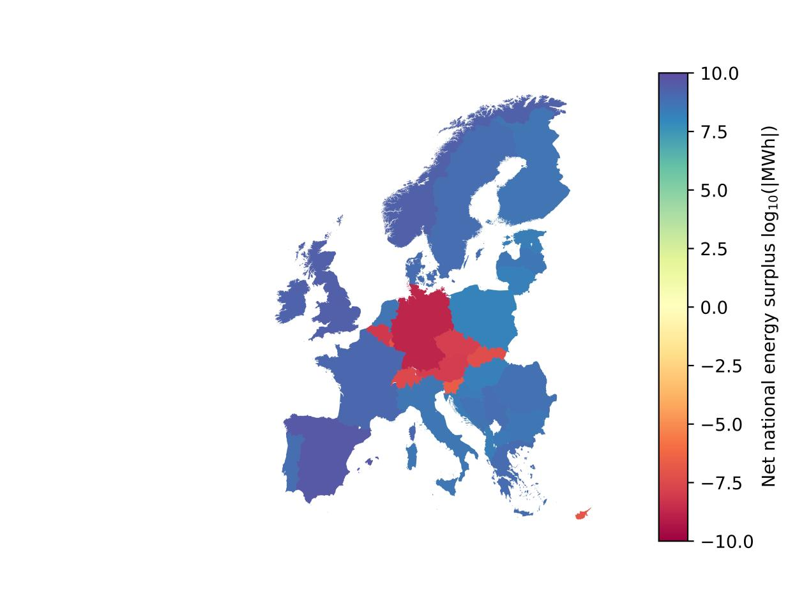

Figure 3 Annual net national energy surplus in Europe

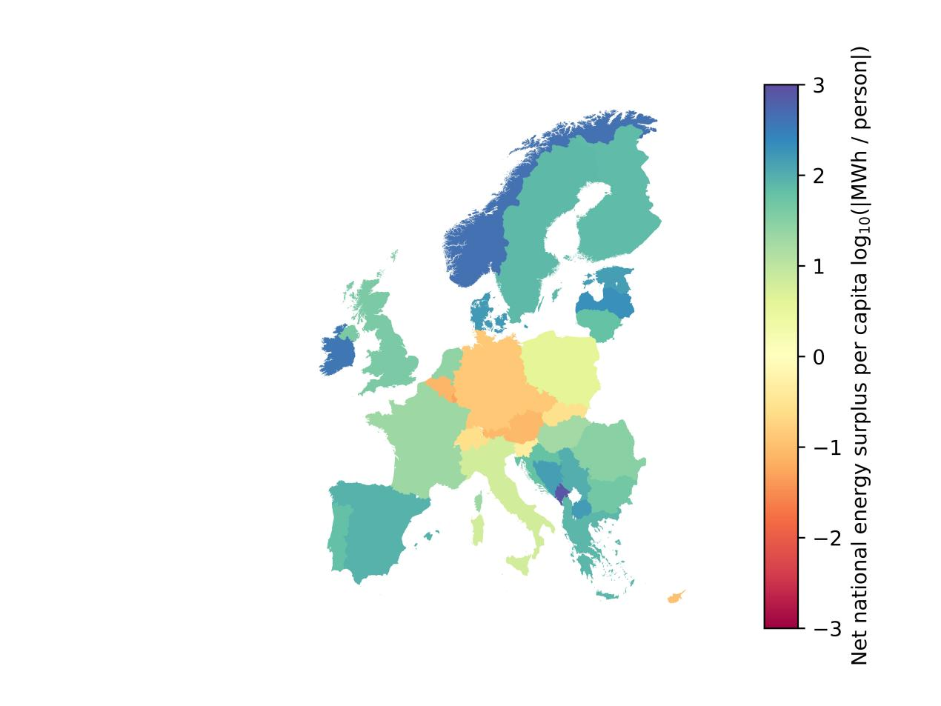

Figure 4 Annual net national energy surplus per capita in Europe

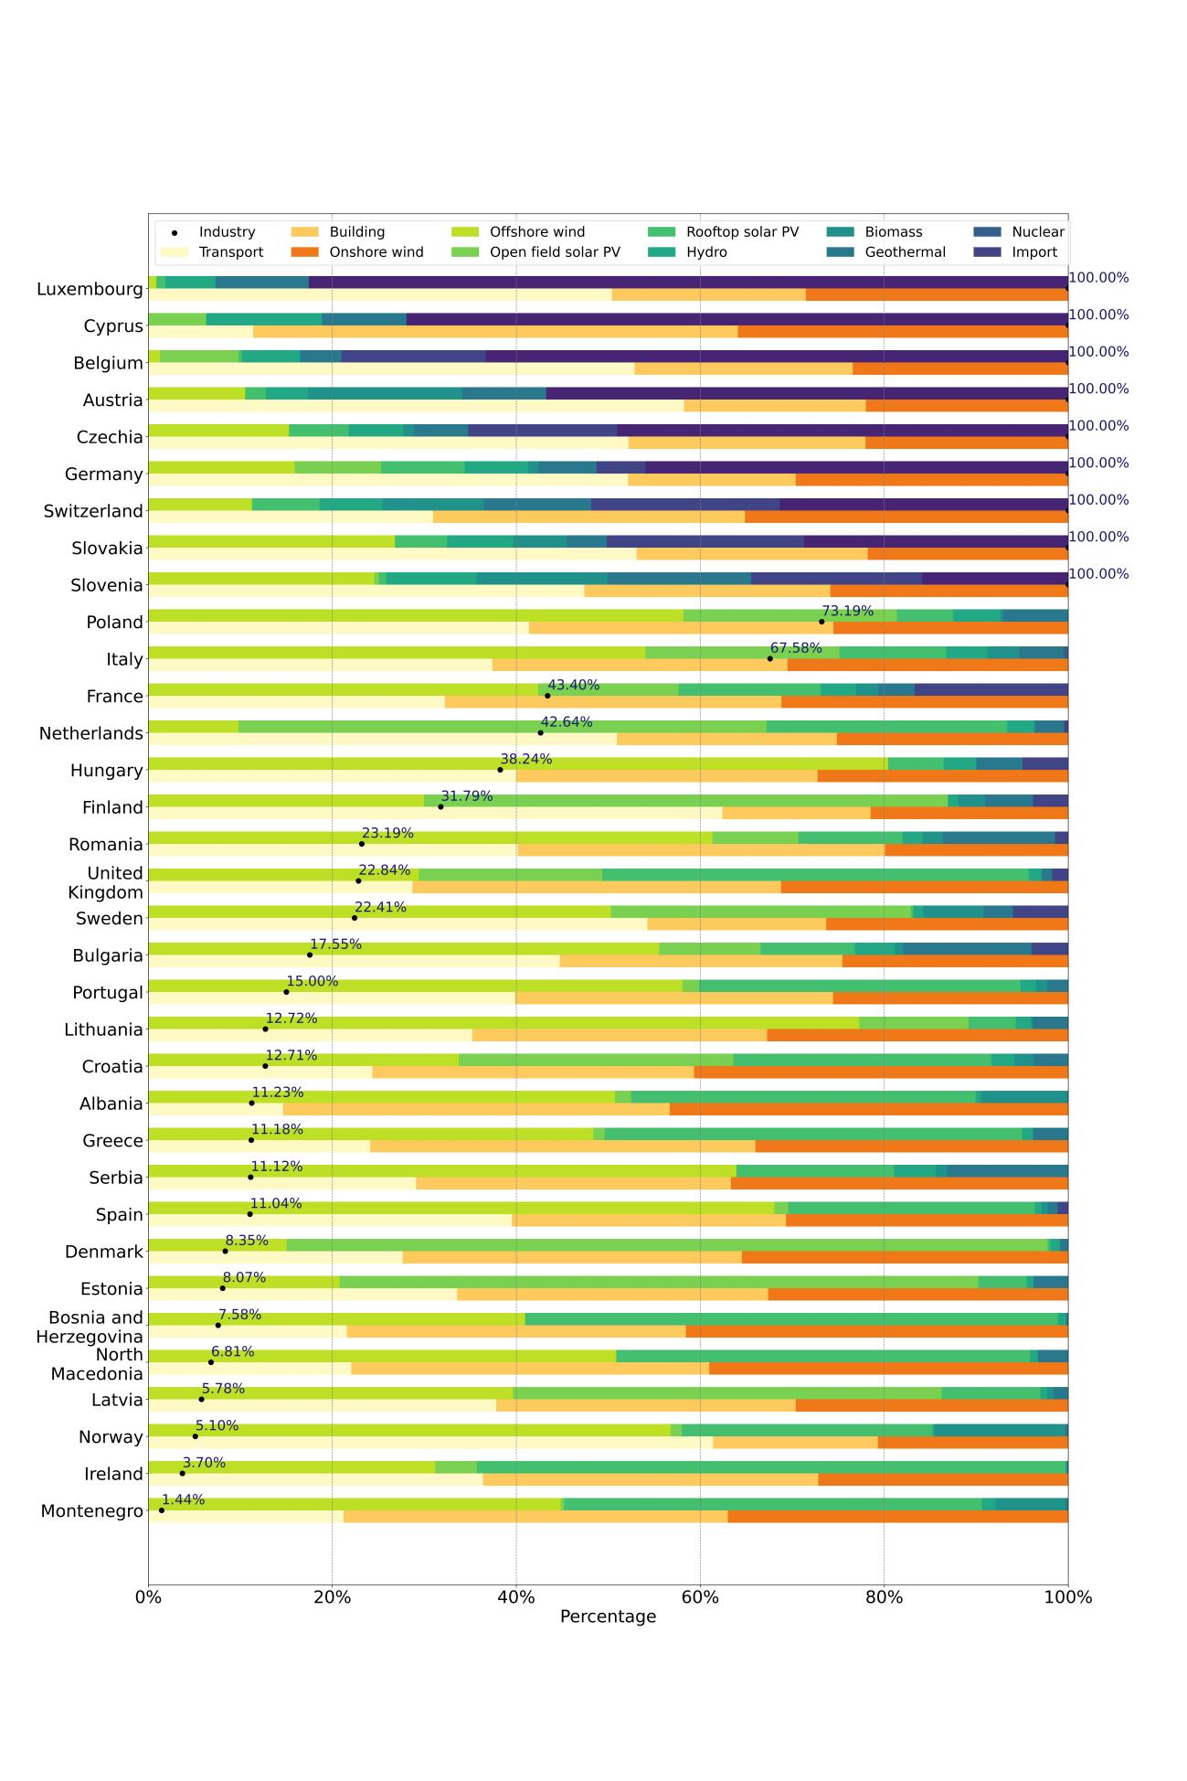

Figure 5 Energy supply and demand structure in Europe

Figure 5 shows the projected national energy supply and demand structure of studied countries according to the modeling results. For each country, the first stacked horizontal bars represent the percentage of different clean electricity suppliers; while the second rows display the share of electricity demand in the industry, transport and building sector respectively. The black points with percentage are the minimum exploit rate of their clean energy potentials to reach autarky. For example, Italy would need to exploit at least 67.58% of its total clean energy potential to become energy-autarkic; while Montenegro only needs to use 1.44% of its total clean energy potential; but for countries that are unable to become energy-autarkic, they would need to develop 100% of their clean energy potentials to achieve the highest possible level of autarky with the imported electricity covering the deficit.

According to Figure 5, onshore wind power is the largest source of clean energy potentials in 50% (17 out of 34) countries. But for Denmark, Estonia, Finland, Latvia and Netherlands, offshore wind power is the mainstay of clean energy supply; for Bosnia and Herzegovina, the United Kingdom, Ireland and Montenegro, open field solar PV dominates. There are also some special cases, in Austria hydropower still takes the lead and in Belgium nuclear power accounts for the largest share. However, some countries are so heavily dependent on imported energy that no home-made clean energy sources are larger than imported energy. This situation may occur in Cyprus, Czech Republic, Germany, Luxembourg, Slovakia and Switzerland. On the demand side, the industry sector consumes the most energy in 20 out of 34 countries; while in 8 countries, the transport sector takes the lead and in 6 countries the building sector makes up the largest share.

On the regional level, 72.59% of all European regions (376 out of 518) have the potential to achieve energy autarky, but with uneven distribution among countries. As Figure 6 shows, in 9 countries, more than half of their national regions cannot reach energy autarky; while in 12 countries, energy autarky is feasible in almost all of their regions (fliers are not displayed). These figures mean that some regions would have to connect their grid to large-scale electricity systems to reach energy sufficiency; considering that energy autarky is not feasible in some countries, some regions with energy deficit in these countries may need to connect with foreign regions - even distant and non-contiguous ones. Figure 7 and Figure 8 show the total annual regional net energy surplus and net energy surplus per capita in Europe. It can be seen from the figures that energy deficit typically occurs in economically developed and densely populated areas in Europe, such as the major part of the “Blue Banana” region, Southern Sweden and Finland, as well as some metropolia like Rome, Paris and Madrid.

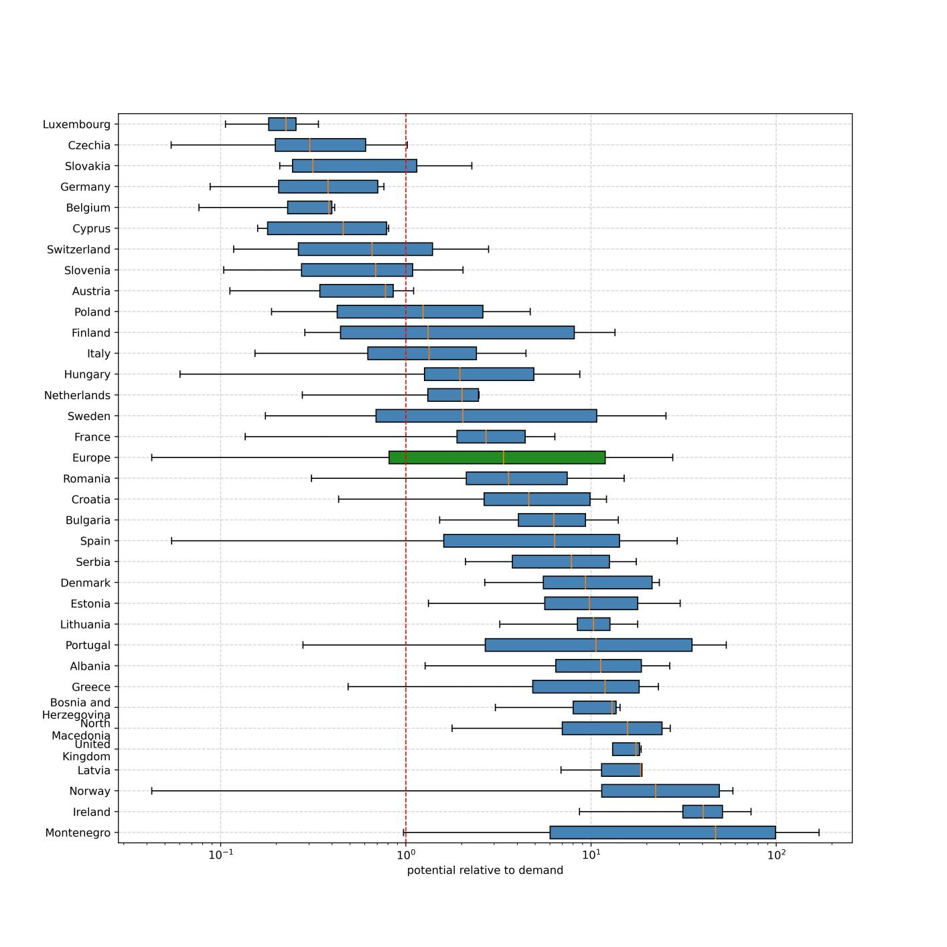

Figure 6 Distribution of regional energy potential per country in Europe

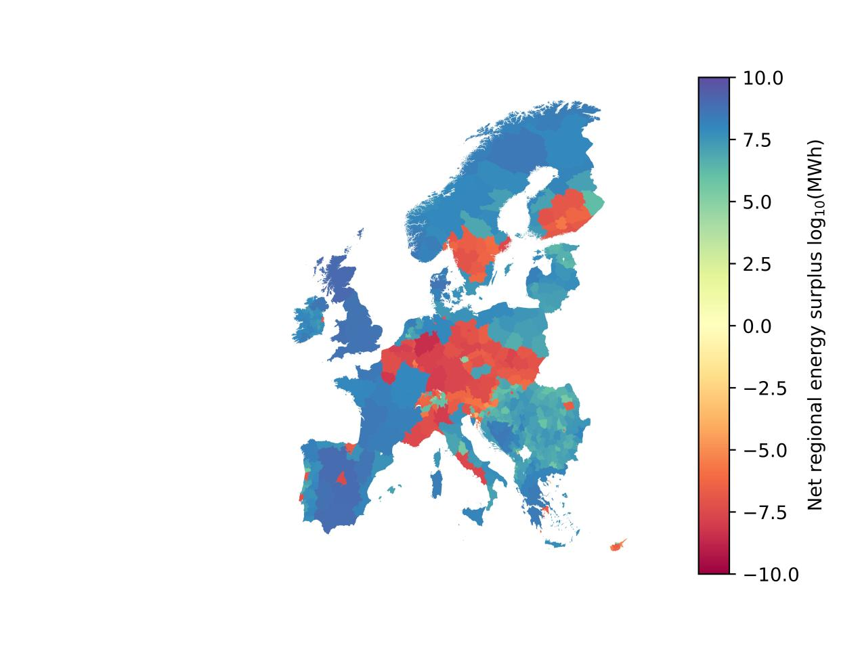

Figure 7 Annual net regional energy surplus in Europe

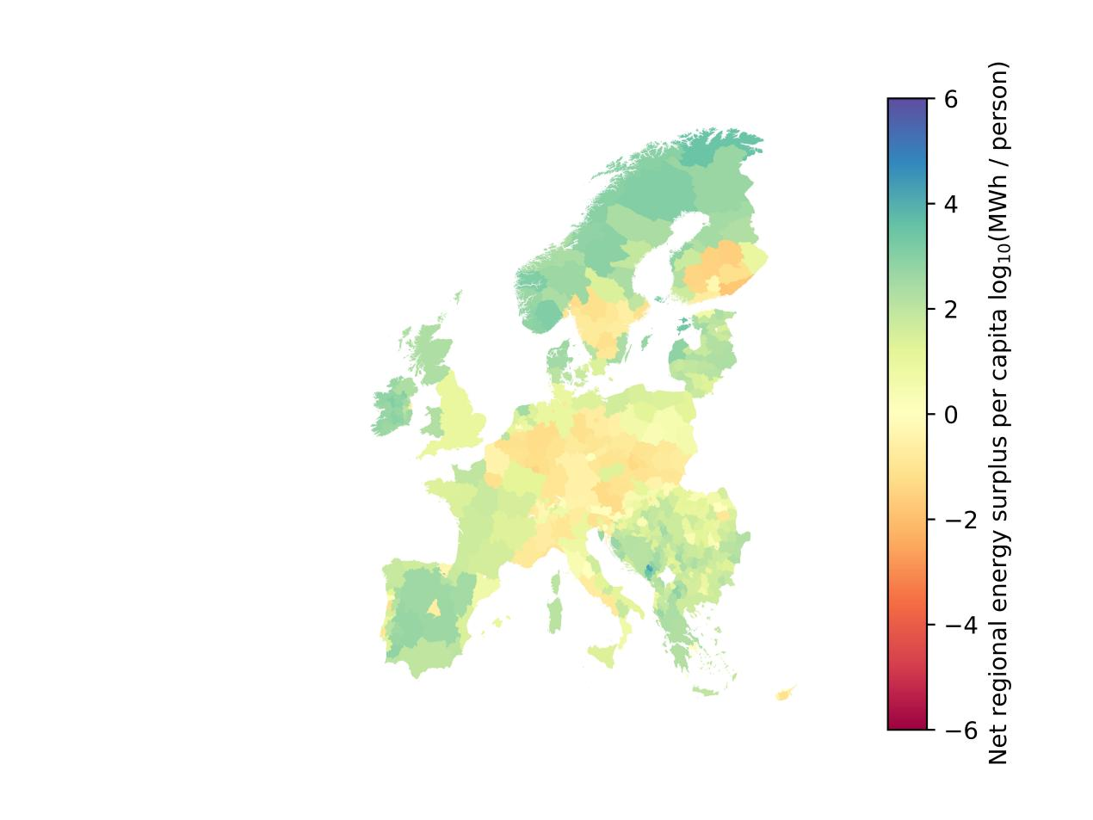

Figure 8 Annual net regional energy surplus per capita in Europe

On the municipal level, only 53.13% (95396 out of 179559) of municipalities in Europe can reach energy autarky. As Figure 9 shows, in 20 countries, energy autarky is feasible in more than half of their municipalities; while no countries can realize energy autarky in all of their municipalities. A clear trend can be observed that the percentage of units which can achieve energy autarky on their administrative level decreases from the continental level to the municipal level. Therefore, the municipal grids often need to be connected to the adjacent or higher-level grids to be energy-sufficient. Figure 10 and Figure 11 show the total annual municipal energy net energy surplus and annual regional energy net energy surplus per capita in Europe. It can be seen from the figures that an energy deficit typically occurs in economically developed and densely populated areas, which fits well with the distribution of cities in Europe.

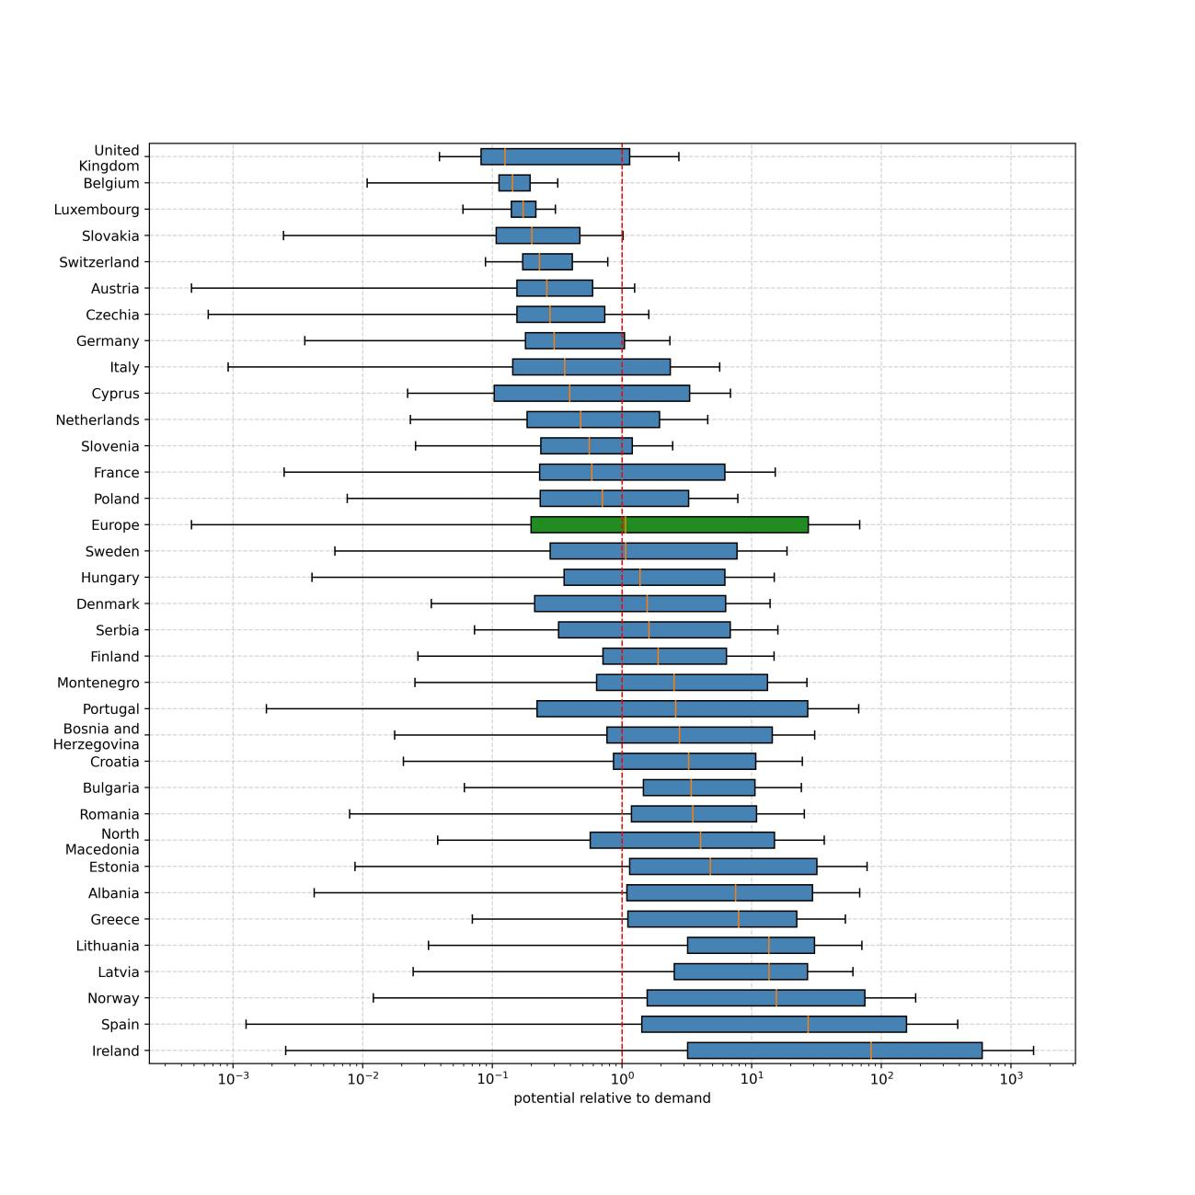

Figure 9 Distribution of municipal energy potential per country in Europe

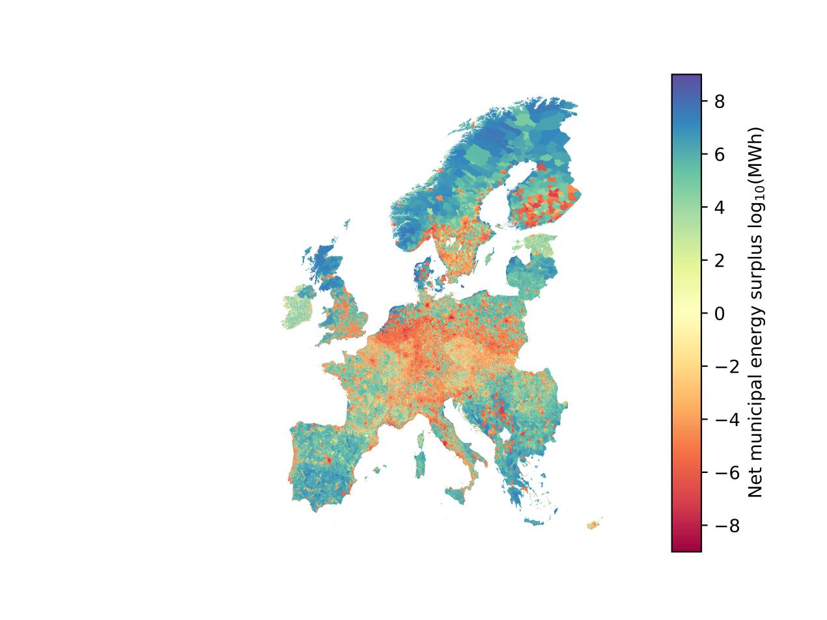

Figure 10 Annual net municipal energy surplus per capita in Europe

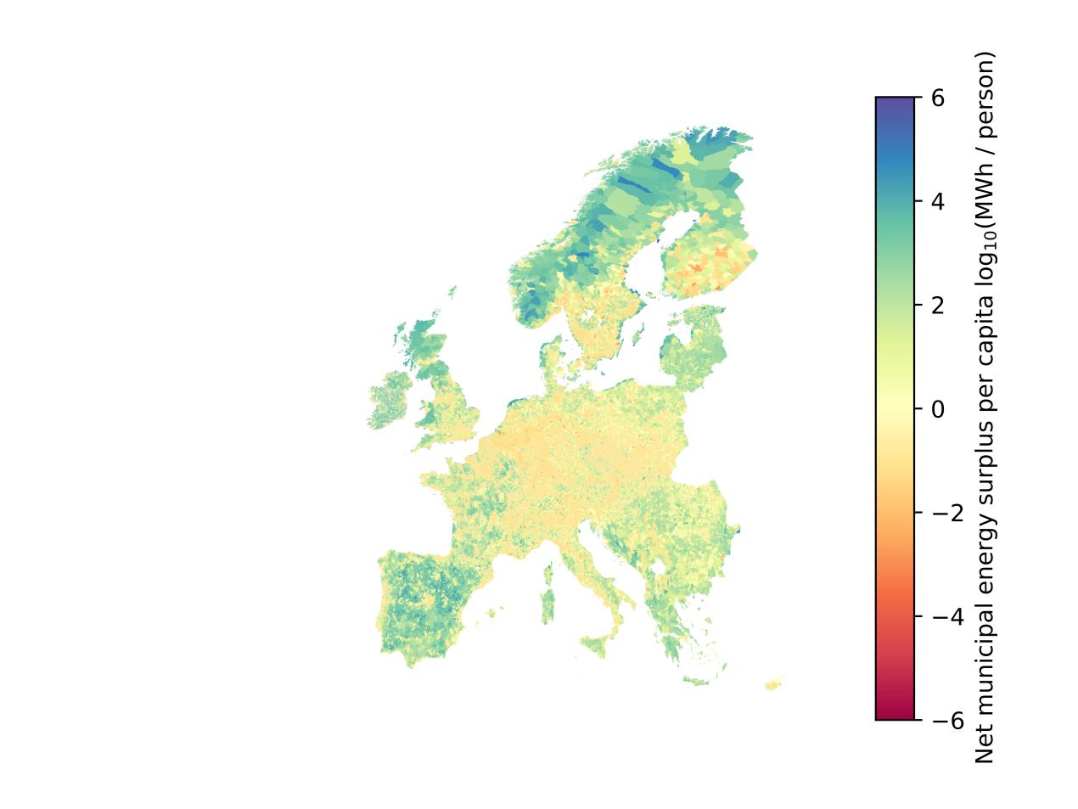

Figure 11 Annual net municipal energy surplus per capita in Europe

1. **Discussion and Conclusions**

This study concludes that clean energy autarky is highly feasible for Europe on the continental level, even assuming a future energy demand scenario where most of the energy uses are electrified. But on the national level, many countries located in central Europe can not achieve clean energy autarky. They need to import energy from nearby countries to be energy-sufficient unless local areas are willing to designate more land than normal cases for energy production. If local clean energy autarky is abandoned, it is more recommended to import energy from neighbors with both high total energy net energy surplus as well as energy net energy surplus per capita, which is to provide buffers for future increases in energy demand. On the regional level, economically developed or densely populated regions are significantly less likely to reach clean energy autarky, as higher population usually entails higher energy consumption and less available land for renewable energy production. On the municipal level, typically, rural municipalities can be clean energy autarkic while urban municipalities have to be dependent on imported energy. An obvious trend is, the share of clean energy autarkic administrative units decreases with lower administrative level, which means that clean energy autarky is more feasible and achievable on higher administrative or geographical levels.

When assessing the potential of clean energy autarky in a certain administrative unit, it is important not to underestimate the future electricity demand. As renewable energy is mainly spread through electricity, most of the energy uses will be electrified in a fully decarbonized energy system, which will result in a significant increase in the grid load, which may even exceed today’s demand by 100% - 200%, making their administrative unit unable to be autarkic at all despite their seemingly abundant renewable energy supply. The results of this study show that the potential future electricity consumption in the building sector alone would be two-thirds of the electricity consumption in Europe today, even with very efficient electric heat pumps; while the increase of electricity consumption from road and rail transport electrification can also achieve a similar amount. These ‘gray rhinos’ of electricity demand are prone to be overlooked, but they are vital to an administrative unit’s ability to achieve clean energy autarky. In terms of the energy security, connecting local grids to a higher level of grid should be a safer choice.

The third finding in this study is that onshore wind power, open-field solar PV and offshore wind power are the apparent mainstays of the future fleet of electricity suppliers; while the generation from rooftop solar PV and biomass power generally don’t hold very high shares. This finding implies that the annual electricity supply in an administrative unit depends highly on how much land or sea can be allocated for wind or solar installations, which is an important decision basis when an administrative unit chooses to be clean energy autarkic or not.

* 1. National energy policy implications

Although on the continental level, the supply of clean energy is abundant relative to demand. On the national level, however, the situation varies considerably from country to country. If a certain country is to achieve as much energy autarky as possible, it needs to choose policies that are appropriate to its renewable energy supply potentials. The following section analyses the energy supply situation in each country and provides possible solutions. Countries are discussed in alphabetic order.

In Albania, at least 11.23% of the total clean energy potential needs to be exploited to achieve theoretical autarky for the country. On the supply side, onshore wind power and open field solar PV account for 50.73% and 37.47% of the total potential respectively. To achieve energy autarky on the national level, more potentials from onshore wind power and open field solar PV need to be exploited; some of the energy surplus can be considered for export to nearby countries or for other energy uses like green hydrogen or synthetic fuels production. On subnational levels, clean energy autarky is possible for almost all the regions and most of the municipalities, most units can include energy autarky as an option when designing their energy policy.

In Austria, 56.76% of the energy needs to be imported to reach energy sufficiency. Among the home-made energy sources, hydropower and onshore wind power account for 16.74% and 10.53% of the total potential respectively. To decrease energy dependency on foreign countries, the existing renewable potentials (especially onshore wind power) should be exploited as much as possible. If energy autarky is abandoned, electricity imports from Italy, Hungry or the Balkans could be considered. On subnational levels, clean energy autarky is unfeasible for most of the regions and municipalities, most administrative units would have to merge their grids into larger interconnected electricity systems.

In Belgium, 63.33% of the energy needs to be imported to reach energy sufficiency. Among the home-made energy sources, nuclear power and offshore wind power account for 15.68% and 8.55% of the total potential respectively. To decrease energy dependency on foreign countries, the existing renewable potentials (especially offshore wind power) should be exploited as much as possible. If energy autarky is abandoned, electricity imports from the United Kingdom, the Nordic countries, Netherlands or France could be considered.On subnational levels, clean energy autarky is unfeasible for almost all of the regions and municipalities, these administrative units would have to merge their grids into larger interconnected electricity systems.

In Bosnia and Herzegovina, at least 7.58% of the total clean energy potential needs to be exploited to achieve theoretical autarky for the country. On the supply side, open field solar PV and onshore wind power account for 57.94% and 40.94% of the total potential respectively. To achieve energy autarky on the national level, more potentials from open field solar PV and onshore wind power need to be exploited; some of the energy surplus can be considered for export to nearby countries or for other energy uses like green hydrogen or synthetic fuels production. On subnational levels, clean energy autarky is possible for almost all the regions and most of the municipalities, most units can include energy autarky as an option when designing their energy policy.

In Bulgaria, at least 17.55% of the total clean energy potential needs to be exploited to achieve theoretical autarky for the country. On the supply side, onshore wind power accounts for 55.52% of the total potential, while biomass power, offshore wind power and open field solar PV account for 13.93%, 11.04% and 10.25% respectively. To achieve energy autarky on the national level, more potentials from onshore wind power need to be exploited; some of the energy surplus can be considered for export to nearby countries or for other energy uses like green hydrogen or synthetic fuels production. On subnational levels, clean energy autarky is possible for almost all the regions and most of the municipalities, most units can include energy autarky as an option when designing their energy policy.

In Croatia, at least 12.71% of the total clean energy potential needs to be exploited to achieve theoretical autarky for the country. On the supply side, onshore wind power, offshore wind power and open field solar PV account for 33.74%, 29.85% and 28.04% of the total potential respectively. To achieve energy autarky on the national level, more potentials from onshore wind power, offshore wind power and open field solar PV need to be exploited; some of the energy surplus can be considered for export to nearby countries or for other energy uses like green hydrogen or synthetic fuels production. On subnational levels, clean energy autarky is possible for most of the regions and municipalities, most units can include energy autarky as an option when designing their energy policy.

In Cyprus, 71.93% of the energy needs to be imported to reach energy sufficiency. Among the home-made energy sources, rooftop solar PV, biomass power and offshore wind power account for 12.57%, 9.21%, 6.29% of the total potential respectively. To decrease energy dependency on foreign countries, all the existing renewable potentials should be exploited as much as possible. If energy autarky is abandoned, electricity imports from the Balkans could be considered. On subnational levels, clean energy autarky is unfeasible for almost all of the regions and most of the municipalities, most administrative units should consider to merge their grids into larger interconnected electricity systems.

In Czech Republic, 49.03% of the energy needs to be imported to reach energy sufficiency. Among the home-made energy sources, nuclear power and onshore wind power account for 16.19% and 15.30% of the total potential respectively. To decrease energy dependency on foreign countries, the existing renewable potentials (especially onshore wind power) should be exploited as much as possible, while current nuclear power capacity is recommended to be maintained. If energy autarky is abandoned, electricity imports from the Balkans could be considered. On subnational levels, clean energy autarky is unfeasible for most of the regions and municipalities, most administrative units would have to merge their grids into larger interconnected electricity systems.

Denmark also has a significant amount of national net clean energy surplus, at least 8.35% of the potential needs to be exploited to achieve theoretical energy autarky for the country. On the supply side, offshore wind power and onshore wind power account for 82.71% and 15.04% of the total potential respectively. To achieve energy autarky on the national level, Denmark mainly needs to develop the more economically efficient fraction of the offshore and onshore wind power; some of the energy surplus can be considered for export to nearby countries like Germany, Belgium and Luxembourg, or for other energy uses like green hydrogen or synthetic fuels production. On subnational levels, clean energy autarky is possible for almost all the regions and most of the municipalities. Coastal administrative units are more recommended to use offshore wind power to become energy-autarkic when economic costs are bearable.

In Estonia, at least 8.07% of the total clean energy potential needs to be exploited to achieve theoretical autarky for the country. On the supply side, offshore and onshore wind power account for 69.43% and 20.80% of the total potential respectively. To achieve energy autarky on the national level, more potentials from offshore and onshore wind power need to be exploited; some of the energy surplus can be considered for export to nearby countries or for other energy uses like green hydrogen or synthetic fuels production. On subnational levels, clean energy autarky is possible for almost all the regions and most of the municipalities, most units can include energy autarky as an option when designing their energy policy.

In Finland, at least 31.79% of the total clean energy potential needs to be exploited to achieve theoretical autarky for the country. On the supply side, offshore and onshore wind power account for 56.96% and 29.95% of the total potential respectively. To achieve energy autarky on the national level, more potentials from offshore and onshore wind power need to be exploited; some of the energy surplus can be considered for export to nearby countries or for other energy uses like green hydrogen or synthetic fuels production. On subnational levels, clean energy autarky is possible for most of the regions and municipalities, most units can include energy autarky as an option when designing their energy policy.

France is the country with the fifth most national net clean energy surplus, but at least 43.40% of the potential needs to be exploited to achieve theoretical energy autarky for the country. On the supply side, onshore wind power, nuclear power, open field solar PV and offshore wind power account for 42.37%, 16.71%, 15.48% and 15.25% of the total potential respectively. To achieve energy autarky on the national level, France mainly needs to develop the more economically efficient fraction of the onshore wind power, open field solar PV and offshore wind power, while considering to maintain some of the nuclear power capacity; some of the energy surplus can be considered for other energy uses like green hydrogen or synthetic fuels production. On subnational levels, clean energy autarky is possible for most of the regions but rather unfeasible for most of the municipalities, these administrative units need to consider how much net clean energy surplus they have before deciding to pursue energy autarky.

In Germany, 45.98% of the energy needs to be imported to reach energy sufficiency. Among the home-made energy sources, onshore wind power, offshore wind power, open field solar PV and rooftop solar PV account for 15.90%, 9.38%, 9.12% and 6.88% of the total potential respectively. To decrease energy dependency on foreign countries, all the existing renewable potentials should be exploited as much as possible. If energy autarky is abandoned, electricity imports from the Nordic countries could be considered. On subnational levels, clean energy autarky is unfeasible for most of the regions and municipalities, these administrative units would have to merge their grids into larger interconnected electricity systems. But administrative units in Northern Germany have higher possibility to reach energy autarky.

In Greece, at least 11.18% of the potential needs to be exploited to achieve theoretical energy autarky for the country. On the supply side, onshore wind power and open field solar PV account for 48.34% and 45.38% of the total potential respectively. To achieve energy autarky on the national level, Greece mainly needs to develop the more economically efficient fraction of the onshore wind power and open field solar PV; some of the energy surplus can be considered for export to nearby countries or for other energy uses like green hydrogen or synthetic fuels production. On subnational levels, clean energy autarky is possible for most of the regions and municipalities, most units can include energy autarky as an option when designing their energy policy.

In Hungary, at least 38.24% of the total clean energy potential needs to be exploited to achieve theoretical autarky for the country. On the supply side, onshore wind power accounts for 80.41% of the total potential. To achieve energy autarky on the national level, more potentials from onshore wind power need to be exploited; energy surplus is recommended to be reserved for future energy demand increment or for other energy uses like green hydrogen or synthetic fuels production. On subnational levels, clean energy autarky is possible for most of the regions and municipalities, most units can include energy autarky as an option when designing their energy policy.

Ireland is the country with the fourth most national net clean energy surplus, at least 3.70% of the potential needs to be exploited to achieve theoretical energy autarky for the country. On the supply side, open field solar PV and onshore wind power account for 63.97% and 31.17% of the total potential respectively. To achieve energy autarky on the national level, Ireland mainly needs to develop the more economically efficient fraction of the open field solar PV and onshore wind power; some of the energy surplus can be considered for other energy uses like green hydrogen or synthetic fuels production. On subnational levels, clean energy autarky is possible for almost all the regions and most of the municipalities, most units can include energy autarky as an option when designing energy policy

In Italy, at least 67.58% of the total clean energy potential needs to be exploited to achieve theoretical autarky for the country. On the supply side, onshore wind power, offshore wind power and open field solar PV account for 54.03%, 21.09% and 11.06% of the total potential respectively. To achieve energy autarky on the national level, more potentials from onshore wind power, offshore wind power and open field solar PV need to be exploited; energy surplus is recommended to be reserved for future energy demand increment or for other energy uses like green hydrogen or synthetic fuels production. On subnational levels, clean energy autarky is possible for most the regions but a small share of the municipalities, these administrative units need to consider how much net clean energy surplus they have before deciding to pursue energy autarky.

In Latvia, at least 5.78% of the total clean energy potential needs to be exploited to achieve theoretical autarky for the country. On the supply side, offshore and onshore wind power account for 46.59% and 39.63% of the total potential respectively. To achieve energy autarky on the national level, more potentials from offshore and onshore wind power need to be exploited; some of the energy surplus can be considered for export to nearby countries or for other energy uses like green hydrogen or synthetic fuels production. On subnational levels, clean energy autarky is possible for almost all the regions and most of the municipalities, most units can include energy autarky as an option when designing their energy policy.

In Lithuania, at least 12.72% of the total clean energy potential needs to be exploited to achieve theoretical autarky for the country. On the supply side, onshore wind power and offshore wind power account for 77.28% and 11.87% of the total potential respectively. To achieve energy autarky on the national level, more potentials from onshore wind power and offshore wind power need to be exploited; some of the energy surplus can be considered for export to nearby countries or for other energy uses like green hydrogen or synthetic fuels production. On subnational levels, clean energy autarky is possible for almost all the regions and most of the municipalities, most units can include energy autarky as an option when designing their energy policy.

In Luxembourg, 82.56% of the energy needs to be imported to reach energy sufficiency. Among the home-made energy sources, biomass power and rooftop solar PV account for 10.14% and 5.45% of the total potential respectively. To decrease energy dependency on foreign countries, the existing renewable potentials should be exploited as much as possible. If energy autarky is abandoned, electricity imports from the France or Netherlands could be considered. On subnational levels, clean energy autarky is unfeasible for almost all of the regions and municipalities, almost all administrative units have to merge their grids into larger interconnected electricity systems.

In Montenegro, at least 1.44% of the total clean energy potential needs to be exploited to achieve theoretical autarky for the country. On the supply side, open field solar PV and onshore wind power account for 45.41% and 44.81% of the total potential respectively. To achieve energy autarky on the national level, current hydropower is actually enough, but more potential can be exploited from open field solar PV and onshore wind power; some of the energy surplus can be considered for export to nearby countries or for other energy uses like green hydrogen or synthetic fuels production. On subnational levels, clean energy autarky is possible most of the regions and municipalities, these administrative units need to consider how much net clean energy surplus they have before deciding to pursue energy autarky.

In Netherlands, at least 42.64% of the total clean energy potential needs to be exploited to achieve theoretical autarky for the country. On the supply side, offshore wind power and open field solar PV account for 57.40% and 26.14% of the total potential respectively. To achieve energy autarky on the national level, more potentials from offshore wind power and open field solar PV need to be exploited; energy surplus is recommended to be reserved for future energy demand increment or for other energy uses like green hydrogen or synthetic fuels production. On subnational levels, clean energy autarky is possible for most the regions but a small share of the municipalities, these administrative units need to consider how much net clean energy surplus they have before deciding to pursue energy autarky.

In North Macedonia, at least 6.81% of the total clean energy potential needs to be exploited to achieve theoretical autarky for the country. On the supply side, onshore wind power and open field solar PV account for 50.86% and 44.97% of the total potential respectively. To achieve energy autarky on the national level, more potentials from onshore wind power and open field solar PV need to be exploited; some of the energy surplus can be considered for export to nearby countries or for other energy uses like green hydrogen or synthetic fuels production. On subnational levels, clean energy autarky is possible for almost all the regions and most of the municipalities, most units can include energy autarky as an option when designing their energy policy.

Norway is the country with the third most national net clean energy surplus, at least 5.10% of the potential needs to be exploited to achieve theoretical energy autarky for the country. On the supply side, open field solar PV, onshore wind power and hydropower account for 56.77%, 27.26% and 14.26% of the total potential respectively. To achieve energy autarky on the national level, Norway mainly needs to develop the more economically efficient fraction of the open field solar PV and onshore wind power, while maintaining the current capacity of hydropower; some of the energy surplus can be considered for export to other nearby countries like Germany. On subnational levels, clean energy autarky is possible for almost all the regions and most of the municipalities, most units can include energy autarky as an option when designing their energy policy.

In Poland, at least 73.19% of the total clean energy potential needs to be exploited to achieve theoretical autarky for the country. On the supply side, onshore wind power and offshore wind power account for 58.16% and 23.21% of the total potential respectively. To achieve energy autarky on the national level, more potentials from onshore wind power and offshore wind power need to be exploited; energy surplus is recommended to be reserved for future energy increment or for other energy uses like green hydrogen or synthetic fuels production. On subnational levels, clean energy autarky is possible for most the regions but less than half of the municipalities, these administrative units need to consider how much net clean energy surplus they have before deciding to pursue energy autarky.

In Portugal, at least 15.00% of the total clean energy potential needs to be exploited to achieve theoretical autarky for the country. On the supply side, onshore wind power and open field solar PV account for 58.06% and 34.92% of the total potential respectively. To achieve energy autarky on the national level, Portugal mainly needs to develop the more economically efficient fraction of the onshore wind power and open field solar PV; some of the energy surplus can be considered for export to nearby countries or for other energy uses like green hydrogen or synthetic fuels production. On subnational levels, clean energy autarky is possible for most of the regions and municipalities, most units can include energy autarky as an option when designing their energy policy.

In Romania, at least 23.19% of the total clean energy potential needs to be exploited to achieve theoretical autarky for the country. On the supply side, onshore wind power, biomass power and open field solar PV account for 61.32%, 12.19% and 11.35% of the total potential respectively. To achieve energy autarky on the national level, Romania mainly needs to develop the more economically efficient fraction of the onshore wind power, biomass power and open field solar PV; some of the energy surplus can be considered for export to nearby countries or for other energy uses like green hydrogen or synthetic fuels production. On subnational levels, clean energy autarky is possible most of the regions and municipalities, most units can include energy autarky as an option when designing their energy policy.

In Serbia, at least 11.12% of the total clean energy potential needs to be exploited to achieve theoretical autarky for the country. On the supply side, onshore wind power, open field solar PV and biomass power account for 63.92%, 17.13% and 13.17% of the total potential respectively. To achieve energy autarky on the national level, Serbia mainly needs to develop the more economically efficient fraction of the onshore wind power, open field solar PV and biomass power; some of the energy surplus can be considered for export to nearby countries or for other energy uses like green hydrogen or synthetic fuels production. On subnational levels, clean energy autarky is possible for almost all the regions and most of the municipalities, most units can include energy autarky as an option when designing energy policy

In Slovakia, 28.70% of the energy needs to be imported to reach energy sufficiency. Among the home-made energy sources, onshore wind power and nuclear power account for 26.81% and 21.46% of the total potential respectively. To decrease energy dependency on foreign countries, the existing onshore wind potential should be exploited as much as possible. If energy autarky is abandoned, electricity imports from Hungary, Poland or the Balkans could be considered. On subnational levels, clean energy autarky is unfeasible for most of the regions and municipalities, most administrative units would have to merge their grids into larger interconnected electricity systems.

In Slovenia, 15.88% of the energy needs to be imported to reach energy sufficiency. Among the home-made energy sources, onshore wind power, nuclear power, biomass power and hydropower account for 24.57%, 18.60%, 15.62% and 14.23% of the total potential respectively. To decrease energy dependency on foreign countries, the existing potential of onshore wind and biomass power should be exploited as much as possible. If energy autarky is abandoned, electricity imports from Hungary, Italy or the Balkans could be considered. On subnational levels, clean energy autarky is unfeasible for most of the regions and municipalities, most administrative units should consider to merge their grids into larger interconnected electricity systems.

Spain is the country with the most national net clean energy surplus, at least 11.04% of the potential needs to be exploited to achieve theoretical energy autarky for the country. On the supply side, onshore wind power and open field solar PV account for 68.04% and 26.81% of the total potential respectively, one of these alone can cover all the energy demand with huge surplus. To achieve energy autarky on the national level, Spain mainly needs to develop the more economically efficient fraction of the onshore wind and open field solar PV; some of the energy surplus can be considered for export to other countries, or for other energy uses like green hydrogen or synthetic fuels production. On subnational levels, clean energy autarky is possible for most of the regions or municipalities, which provides these administrative units with more options when designing their energy policy.

In Sweden, at least 22.41% of the total clean energy potential needs to be exploited to achieve theoretical autarky for the country. On the supply side, onshore and offshore wind power account for 50.28% and 32.61% of the total potential respectively. To achieve energy autarky on the national level, Sweden mainly needs to develop the more economically efficient fraction of the onshore and offshore wind power; some of the energy surplus can be considered for export to nearby countries or for other energy uses like green hydrogen or synthetic fuels production. On subnational levels, clean energy autarky is possible most of the regions and about half of the municipalities, the administrative units need to consider how much net clean energy surplus they have before deciding to pursue energy autarky.

In Switzerland, 31.35% of the energy needs to be imported to reach energy sufficiency. Among the home-made energy sources, nuclear power, onshore wind power and hydropower account for 20.52%, 11.27% and 11.00% of the total potential respectively. To decrease energy dependency on foreign countries, the existing renewable potentials should be exploited as much as possible. If energy autarky is abandoned, electricity imports from France or Italy could be considered. On subnational levels, clean energy autarky is unfeasible for most of the regions and municipalities, most administrative units would have to merge their grids into larger interconnected electricity systems.

The United Kingdom is the country with the second most national net clean energy surplus, at least 22.84% of the potential needs to be exploited to achieve theoretical energy autarky for the country. On the supply side, open field solar PV, onshore wind power and offshore power account for 46.35%, 29.41% and 19.94% of the total potential respectively, open field solar PV or onshore wind power can cover all the energy demand on its own. To achieve energy autarky on the national level, the United Kingdom mainly needs to develop the more economically efficient fraction of the open field solar PV, onshore wind power and offshore power; some of the energy surplus can be considered for export to other countries like Belgium and Luxembourg, or for other energy uses like green hydrogen or synthetic fuels production. On subnational levels, clean energy autarky is possible for most of the regions but rather unfeasible for most of the municipalities, these administrative units need to consider how much net clean energy surplus they have before deciding to pursue energy autarky.

* 1. Uncertainties and future research

It is important to note that the electricity demands for synthetic fuels and CCS (carbon capture and storage) are not included in the model of this study. There are two reasons for this treatment. First, it is uncertain which of the two aforementioned technology will prevail and how many shares they will take up. For those applications where it is difficult to electrify energy use, like aviation and shipping fuels as well as raw material fuels in the industry, whether to use hydrogen-based or biomass-based synthetic fuels or to install CCS facilities for the conventional system is unable to determine at this time, which makes an accurate estimation of their corresponding electricity demand difficult. Second, the potential impact of imports and exports with extra-European countries is not in the scope of this analysis. Electricity self-sufficiency is likely to be achieved and even economically viable, but complete physical self-sufficiency is probably not feasible. Assuming a certain amount of synthetic fuels is used, but Europe does not necessarily produce the same amount of fuels as its demand, while the difference can be filled either by imports or exports with external countries.

Besides, the self-sufficiency level for each administrative unit estimated in this study is only a necessary instead of a sufficient condition for judging electricity autarky. Since, in the model, the total annual electricity supply and demand are compared without considering the intra-year fluctuations, curtailment may occur in the case of an inadequate energy storage system. Even if the energy storage system can be fully adapted to the load curve, the actual annual supply of electricity available should shrink further, considering that the round-trip efficiency of the energy storage system cannot reach 100%. This problem needs to be addressed by models with smaller time intervals, for example, in hourly steps, in the future. Besides, socio-political and economic factors can drastically affect the amount of land or sea that can be allocated for renewable energy production, as well as the specifications in the installation of renewables. Some land may not be chosen for wind or solar electricity production, not because it’s technically unproductive, but because of legal restrictions, land ownership, excessive land prices, etc. Regulations to increase the distance of wind or solar PV plants from residential areas or protected areas will also further reduce the available potential; some new areas may be designated as residential, industrial or protected areas, excluding them from power generation uses. All of the possibilities mentioned above would further reduce the estimated energy supply potential, making the clean energy autarky on lower administrative levels less feasible. On the other hand, administrative units can also loosen the land restrictions for renewable energy installations or provide subsidies for originally uneconomic renewables to increase their energy autarky level. This study shows how self-sufficient Europe can be in a future clean electricity supply and demand system on the four administrative levels, but how exactly this system will be formed is still an open question.

1. **Appendix**

Table 1 Data inventory and sources in this study

| **Name** | **Format** | **Source** |
| --- | --- | --- |
| GeoBoundaries Comprehensive Global Administrative Zones | GeoJson | [105] |
| Exclusive economic zone | GeoJson | [106] |
| Maritime military areas | GeoJson | [107] |
| Offshore oil and gas wells | GeoJson | [107] |
| Offshore pipelines | GeoJson | [107] |
| Shorelines in Europe | GeoJson | [108] |
| Protected areas | Shapefile | [109] |
| European settlement map | GeoTIFF | [110] |
| Corine land cover map | GeoTIFF | [111] |
| Bathymetry | GeoTIFF | [112] |
| Maritime traffic density map | GeoTIFF | [107] |
| Population density map | GeoTIFF | [113] |
| Prior data of the GLAES tool | GeoTIFF | [114] |
| ERA reanalysis surface temperature data | NetCDF4 | [115] |
| ERA reanalysis wind speed data | NetCDF4 | [115] |
| Renewables.ninja simulation data | NetCDF4 | [87] |
| JRC-IDEES data | XLSX | [116] |
| ENTSOE-E historical generation data | CSV | [91] |
| Global power plant database | CSV | [117] |
| Historical electricity generation of Albania | CSV | [118] |
| ETS industrial emission inventory | CSV | [119] |
| Biomass annual production | CSV | [120] - [132] |
| Heating threshold temperatures | CSV | [104] |
| When2heat parameters | CSV | [133] |
| House to flat ratio | CSV | [134] |
| Final energy consumption by sector | CSV | [135] |
| National population | CSV | [136] |

Table 2 Land exclusion criteria for onshore wind power

| **Exclusion Criteria** | **Exclusion Range** | **Unit** |
| --- | --- | --- |
| Elevation threshold[137] | (1750, None) | m |
| Slope threshold[137] | (15, None) | degree |
| Wind speed at 100m threshold[138] | (None, 4) | m/s |
| River proximity[139] | (None, 500) | m |
| Lake proximity[140] | (None, 1000) | m |
| Ocean proximity[141] | (None, 1000) | m |
| Sand proximity[141] | (None, 0) | m |
| Wetland proximity[141] | (None, 0) | m |
| Woodland proximity[141] | (None, 300) | m |
| Settlement proximity[141] | (None, 2000) | m |
| Industrial proximity[141] | (None, 2000) | m |
| Mining proximity[141] | (None, 2000) | m |
| Touristic proximity[142] | (None, 2000) | m |
| Camping proximity[142] | (None, 2000) | m |
| Leisure proximity[142] | (None, 2000) | m |
| Railway proximity[142] | (None, 500) | m |
| Main roads proximity[142] | (None, 500) | m |
| Secondary roads proximity[142] | (None, 500) | m |
| Power line proximity[142] | (None, 300) | m |
| Airport proximity[143] | (None, 5000) | m |
| Airfield proximity[143] | (None, 5000) | m |
| Protected park proximity[144] | (None, 1000) | m |
| Protected habitat proximity[144] | (None, 0) | m |
| Protected bird proximity[144] | (None, 0) | m |
| Protected biosphere proximity[144] | (None, 0) | m |
| Protected landscape proximity[144] | (None, 0) | m |
| Protected natural monument proximity[144] | (None, 0) | m |

Note: For threshold criteria, exclusion range is the range of unsuitable values. For example,, (None, 4) for wind speed at 100m threshold means areas where wind speed at 100 m high is smaller than 4 m/s are excluded. For proximity criteria, exclusion range is the range of buffer. For example,, the (None, 5000) for airport proximity means the airport areas, together with buffer areas within 5,000 meters of the airport are excluded.

Table 3 Sea surface exclusion criteria for offshore wind power

|  |  |  |
| --- | --- | --- |
| **Exclusion Criteria** | **Exclusion Range** | **Unit** |
| Bathymetry threshold[147] | (None, -50) | m |
| Shoreline proximity[147] | (0, 10000) & (100000, None) | m |
| Offshore pipeline proximity[147] | (None, 3000) | m |
| Offshore oil and gas well proximity[147] | (None, 3000) | m |
| Maritime military zone proximity[147] | (None, 3000) | m |
| Protected area proximity[147][142] | (None, 3000) | m |

Table 4 Land exclusion criteria for open-field solar PV

| **Exclusion Criteria** | **Exclusion Range** | **Unit** |
| --- | --- | --- |
| Elevation threshold[138] | (1750, None) | m |
| Slope threshold[138] | (15, None) | degree |
| DNI threshold[148] | (None, 1) | kWh/m2/day |
| River proximity[140] | (None, 300) | m |
| Lake proximity[141] | (None, 300) | m |
| Ocean proximity[142] | (None, 1000) | m |
| Wetland proximity[142] | (None, 300) | m |
| Woodland proximity[142] | (None, 300) | m |
| Agriculture permanent crop proximity[142] | (None, 300) | m |
| Agriculture heterogeneous proximity[142] | (None, 300) | m |
| Agriculture arable proximity[142] | (None, 300) | m |
| Settlement proximity[142] | (None, 1000) | m |
| Industrial proximity[142] | (None, 300) | m |
| Mining proximity[142] | (None, 300) | m |
| Touristic proximity[143] | (None, 2000) | m |
| Camping proximity[143] | (None, 300) | m |
| Leisure proximity[143] | (None, 300) | m |
| Railway proximity[143] | (None, 300) | m |
| Main roads proximity[143] | (None, 300) | m |
| Secondary roads proximity[143] | (None, 300) | m |
| Power line proximity[143] | (None, 300) | m |
| Airport proximity[144] | (None, 5000) | m |
| Airfield proximity[144] | (None, 5000) | m |
| Protected park proximity[145] | (None, 1000) | m |
| Protected habitat proximity[145] | (None, 0) | m |
| Protected bird proximity[145] | (None, 0) | m |
| Protected biosphere proximity[145] | (None, 0) | m |
| Protected landscape proximity[145] | (None, 0) | m |
| Protected natural monument proximity[145] | (None, 0) | m |

Table 5 Applied pixel values and proxies in CORINE Land Cover Database

|  |  |  |
| --- | --- | --- |
| **Pixel value** | **Land cover type** | **Proxy for** |
| 12 | Non-irrigated arable land | Wheat, rye, barley, oats, maize, rape, sunflower |
| 13 | Permanently irrigated land |
| 19 | Annual crops associated with permanent crops |
| 20 | Complex cultivation patterns |
| 21 | Land principally occupied by agriculture, with significant areas of natural vegetation |
| 22 | Agro-forestry areas |
| 14 | Rice fields | Rice |
| 15 | Vineyards | Vineyards |
| 16 | Fruit trees and berry plantations | Fruits and berries |
| 17 | Olive groves | Olives |
| 23 | Broad-leaved forest | Round wood, fuel wood |
| 24 | Coniferous forest |
| 25 | Mixed forest |
| 27 | Moors and heathland |
| 28 | Sclerophyllous vegetation |
| 29 | Transitional woodland-shrub |

Table 6 Parameters of agricultural biomass power potential estimation

|  |  |  |  |  |
| --- | --- | --- | --- | --- |
| **Residue type** | **Energy density**  **MWh/t** | **Residue-to-yield ratio** | **Remaining rate** | **actual use rate** |
| Wheat | 4 | 1[68] | 0.4 | 0.3 |
| Rye | 4 | 1.7[68] | 0.4 | 0.3 |
| Barley | 4 | 1[68] | 0.4 | 0.3 |
| Oats | 4 | 1.2[68] | 0.4 | 0.3 |
| Maize | 4 | 0.7[68] | 0.4 | 0.3 |
| Rape | 4 | 1.1[68] | 0.4 | 0.3 |
| Sunflower | 4 | 1.4[68] | 0.4 | 0.3 |
| Rice | 4 | 1[68] | 0.4 | 0.3 |
| Vineyards | 4 | 0.2 | 0.4 | 0.3 |
| Olives | 4 | 0.2 | 0.4 | 0.3 |
| Fruits and berries | 4 | 0.2 | 0.4 | 0.3 |

Table 7 Applied pixel values and proxies in CORINE Land Cover Database

|  |  |  |
| --- | --- | --- |
| **Pixel value** | **Land cover type** | **Proxy for** |
| 23 | Broad-leaved forest | Round wood and fuel wood |
| 24 | Coniferous forest |
| 25 | Mixed forest |
| 27 | Moors and heathland |
| 28 | Sclerophyllous vegetation |
| 29 | Transitional woodland-shrub |

Table 8 Regression parameters of the transport sector

|  |  |  |  |
| --- | --- | --- | --- |
| **Transport type** | **Slope** | **Intercept** | ***r2*** |
| Public passenger transport | 2.39E-05 | 92.38706107 | 0.866398221 |
| Light freight transport | 6.92E-05 | -39.30454747 | 0.730646119 |
| Heavy freight transport | 6.59E-05 | -54.39020849 | 0.71523375 |
| Railway transport using diesel engine | 3.94E-06 | 5.149469007 | 0.508826749 |
| Railway transport using electric engine | 7.44E-06 | -3.431243435 | 0.795792923 |
| Metro and tram | 1.02E-06 | 1.08098129 | 0.733954555 |

Note: E-x stands for xth power of 10

Table 9 BDEW parameters for daily demand factor calculation

|  |  |  |  |  |  |  |
| --- | --- | --- | --- | --- | --- | --- |
| **Building type** | **SFH** | **MFH** | **COM** | **SFH** | **MFH** | **COM** |
| Windiness | normal | normal | normal | windy | windy | windy |
| A | 1.6209544 | 1.2328655 | 1.3010623 | 1.3819663 | 1.0443538 | 1.25696 |
| B | -37.1833141 | -34.7213605 | -35.6816144 | -37.4124155 | -35.0333754 | -36.6078453 |
| C | 5.6727847 | 5.8164304 | 6.6857976 | 6.1723179 | 6.2240634 | 7.321187 |
| D | 0.0716431 | 0.0873352 | 0.1409267 | 0.0396284 | 0.0502917 | 0.077696 |
| *mspace* | -0.04957 | -0.0409284 | -0.0473428 | -0.0672159 | -0.053583 | -0.0696826 |
| *bspace* | 0.8401015 | 0.767292 | 0.8141691 | 1.1167138 | 0.9995901 | 1.1379702 |
| *mwater* | -0.002209 | -0.002232 | -0.0010601 | -0.0019982 | -0.0021758 | -0.0008522 |
| *bwater* | 0.1074468 | 0.1199207 | 0.1325092 | 0.135507 | 0.1633299 | 0.1921068 |

Note: SFH stands for single-family houses, MFH stands for multi-family houses, COM stands for commercial houses.

Table 10 Applied heating threshold values

|  |  |  |  |  |  |
| --- | --- | --- | --- | --- | --- |
| **Country code** | **Heating threshold temperature (℃)** | **Country code** | **Heating threshold temperature (℃)** | **Country code** | **Heating threshold temperature (℃)** |
| AUT | 14.59 | GRC | 16.84 | SWE | 13.16 |
| BEL | 15.2 | HRV | 18.67 | SVN | 15.41 |
| BGR | 16.02 | HUN | 16.84 | SVK | 14.18 |
| CZE | 14.8 | IRL | 12.76 | BIH | 12.76 |
| CHE | 16.84 | ITA | 15.61 | SRB | 17.65 |
| DEU | 13.98 | LTU | 15.2 | CYP | 16.84 |
| DNK | 15.2 | LVA | 12.96 | ALB | 16.02 (BGR) |
| EST | 11.12 | NLD | 13.98 | MKD | 16.02 (BGR) |
| ESP | 18.47 | NOR | 11.53 | MNE | 16.02 (BGR) |
| FIN | 13.16 | POL | 15.2 | LUX | 15.2 (BEL) |
| FRA | 15.61 | PRT | 11.94 |  |  |
| GBR | 14.18 | ROU | 15.41 |  |  |

Table 11 Hourly ratio of SFH according to daily average temperature

|  |  |  |  |  |  |  |  |  |  |  |
| --- | --- | --- | --- | --- | --- | --- | --- | --- | --- | --- |
| **Time/**  **Temperature (℃)** | **-15** | **-10** | **-5** | **0** | **5** | **10** | **15** | **20** | **25** | **30** |
| 0:00 | 0.0296 | 0.0292 | 0.0281 | 0.0262 | 0.023 | 0.0196 | 0.0142 | 0.0096 | 0.0045 | 0.0045 |
| 1:00 | 0.0294 | 0.0289 | 0.0279 | 0.0266 | 0.0237 | 0.0208 | 0.0155 | 0.0105 | 0.0054 | 0.0054 |
| 2:00 | 0.03 | 0.0296 | 0.0286 | 0.0274 | 0.0243 | 0.0217 | 0.0167 | 0.0112 | 0.0044 | 0.0044 |
| 3:00 | 0.0307 | 0.0303 | 0.0294 | 0.0289 | 0.0262 | 0.0249 | 0.02 | 0.0162 | 0.0081 | 0.0081 |
| 4:00 | 0.0321 | 0.0318 | 0.031 | 0.0333 | 0.0312 | 0.0326 | 0.0298 | 0.0289 | 0.0191 | 0.0191 |
| 5:00 | 0.0381 | 0.038 | 0.0377 | 0.043 | 0.0448 | 0.0483 | 0.0541 | 0.0662 | 0.0601 | 0.0601 |
| 6:00 | 0.0577 | 0.0573 | 0.0602 | 0.0551 | 0.0577 | 0.0619 | 0.0685 | 0.0821 | 0.0939 | 0.0939 |
| 7:00 | 0.0525 | 0.053 | 0.0537 | 0.051 | 0.0537 | 0.0578 | 0.0679 | 0.0757 | 0.0809 | 0.0809 |
| 8:00 | 0.0498 | 0.0501 | 0.0507 | 0.0497 | 0.051 | 0.0527 | 0.0578 | 0.0609 | 0.0614 | 0.0614 |
| 9:00 | 0.0476 | 0.0479 | 0.0483 | 0.0482 | 0.0488 | 0.0486 | 0.0527 | 0.0601 | 0.0587 | 0.0587 |
| 10:00 | 0.0466 | 0.0469 | 0.0472 | 0.0467 | 0.0465 | 0.0452 | 0.0478 | 0.0513 | 0.0533 | 0.0533 |
| 11:00 | 0.0437 | 0.0438 | 0.0438 | 0.0446 | 0.0448 | 0.043 | 0.0435 | 0.0483 | 0.0541 | 0.0541 |
| 12:00 | 0.0423 | 0.0424 | 0.0424 | 0.0439 | 0.0438 | 0.0424 | 0.0415 | 0.0442 | 0.0521 | 0.0521 |
| 13:00 | 0.0422 | 0.0422 | 0.0422 | 0.0435 | 0.0437 | 0.0422 | 0.0402 | 0.0397 | 0.042 | 0.042 |
| 14:00 | 0.0418 | 0.0418 | 0.0418 | 0.0448 | 0.0446 | 0.0433 | 0.0399 | 0.0378 | 0.0403 | 0.0403 |
| 15:00 | 0.0438 | 0.0439 | 0.0439 | 0.0456 | 0.0458 | 0.0452 | 0.0414 | 0.0359 | 0.036 | 0.036 |
| 16:00 | 0.0472 | 0.0475 | 0.0478 | 0.0481 | 0.0481 | 0.0478 | 0.0441 | 0.04 | 0.0423 | 0.0423 |
| 17:00 | 0.0482 | 0.0485 | 0.0489 | 0.0489 | 0.0501 | 0.0509 | 0.0477 | 0.0428 | 0.0498 | 0.0498 |
| 18:00 | 0.0472 | 0.0475 | 0.0478 | 0.0491 | 0.0506 | 0.0523 | 0.0515 | 0.0456 | 0.0482 | 0.0482 |
| 19:00 | 0.0469 | 0.0471 | 0.0475 | 0.0484 | 0.0505 | 0.0527 | 0.0552 | 0.0513 | 0.0508 | 0.0508 |
| 20:00 | 0.0461 | 0.0463 | 0.0465 | 0.0466 | 0.0485 | 0.0504 | 0.0535 | 0.0519 | 0.0526 | 0.0526 |
| 21:00 | 0.0423 | 0.0424 | 0.0424 | 0.0414 | 0.043 | 0.044 | 0.0474 | 0.0442 | 0.045 | 0.045 |
| 22:00 | 0.0345 | 0.0343 | 0.0337 | 0.0318 | 0.0309 | 0.0301 | 0.0315 | 0.0309 | 0.0262 | 0.0262 |
| 23:00 | 0.0298 | 0.0294 | 0.0284 | 0.0272 | 0.0246 | 0.0218 | 0.0177 | 0.0147 | 0.0108 | 0.0108 |

Table 12 Hourly ratio of MFH according to daily average temperature

|  |  |  |  |  |  |  |  |  |  |  |
| --- | --- | --- | --- | --- | --- | --- | --- | --- | --- | --- |
| **Time/**  **Temperature (℃)** | **-15** | **-10** | **-5** | **0** | **5** | **10** | **15** | **20** | **25** | **30** |
| 0:00 | 0.0299 | 0.0298 | 0.0291 | 0.0258 | 0.0235 | 0.0225 | 0.0221 | 0.0222 | 0.0246 | 0.0246 |
| 1:00 | 0.0296 | 0.0294 | 0.0288 | 0.0266 | 0.025 | 0.0247 | 0.0215 | 0.022 | 0.0255 | 0.0255 |
| 2:00 | 0.0294 | 0.0292 | 0.0285 | 0.027 | 0.0254 | 0.0235 | 0.0208 | 0.0207 | 0.0247 | 0.0247 |
| 3:00 | 0.0304 | 0.0302 | 0.0296 | 0.0291 | 0.0274 | 0.0258 | 0.0231 | 0.0223 | 0.0237 | 0.0237 |
| 4:00 | 0.0355 | 0.0355 | 0.0352 | 0.0351 | 0.0339 | 0.0346 | 0.0343 | 0.037 | 0.038 | 0.038 |
| 5:00 | 0.0543 | 0.0543 | 0.055 | 0.051 | 0.0506 | 0.0513 | 0.0526 | 0.0548 | 0.0519 | 0.0519 |
| 6:00 | 0.0549 | 0.0525 | 0.0527 | 0.0505 | 0.0504 | 0.0524 | 0.0605 | 0.0602 | 0.044 | 0.044 |
| 7:00 | 0.0459 | 0.0462 | 0.0465 | 0.0478 | 0.049 | 0.0507 | 0.055 | 0.057 | 0.0555 | 0.0555 |
| 8:00 | 0.0459 | 0.0461 | 0.0463 | 0.0487 | 0.0485 | 0.0494 | 0.0521 | 0.0517 | 0.0496 | 0.0496 |
| 9:00 | 0.0447 | 0.0449 | 0.0451 | 0.0479 | 0.0475 | 0.0467 | 0.0487 | 0.0507 | 0.0504 | 0.0504 |
| 10:00 | 0.0423 | 0.0425 | 0.0426 | 0.0464 | 0.0462 | 0.045 | 0.0463 | 0.0474 | 0.0478 | 0.0478 |
| 11:00 | 0.0436 | 0.0438 | 0.0439 | 0.0452 | 0.0446 | 0.0434 | 0.0439 | 0.0452 | 0.0464 | 0.0464 |
| 12:00 | 0.0427 | 0.0429 | 0.043 | 0.0448 | 0.0442 | 0.0426 | 0.0429 | 0.0449 | 0.0466 | 0.0466 |
| 13:00 | 0.0423 | 0.0424 | 0.0424 | 0.0438 | 0.0441 | 0.042 | 0.0416 | 0.0409 | 0.0428 | 0.0428 |
| 14:00 | 0.0419 | 0.0421 | 0.0421 | 0.0437 | 0.0443 | 0.042 | 0.0401 | 0.0404 | 0.0439 | 0.0439 |
| 15:00 | 0.043 | 0.0432 | 0.0432 | 0.0441 | 0.0447 | 0.0432 | 0.0404 | 0.0385 | 0.0398 | 0.0398 |
| 16:00 | 0.0436 | 0.0438 | 0.0439 | 0.0459 | 0.0466 | 0.0455 | 0.0415 | 0.0391 | 0.0392 | 0.0392 |
| 17:00 | 0.0458 | 0.046 | 0.0462 | 0.0473 | 0.0482 | 0.0478 | 0.0436 | 0.041 | 0.042 | 0.042 |
| 18:00 | 0.0453 | 0.0457 | 0.0458 | 0.0479 | 0.0492 | 0.0499 | 0.047 | 0.0444 | 0.0442 | 0.0442 |
| 19:00 | 0.0463 | 0.0466 | 0.0469 | 0.0476 | 0.0491 | 0.0513 | 0.0505 | 0.0474 | 0.0455 | 0.0455 |
| 20:00 | 0.0455 | 0.0458 | 0.0461 | 0.0461 | 0.048 | 0.0509 | 0.0518 | 0.05 | 0.0496 | 0.0496 |
| 21:00 | 0.0432 | 0.0434 | 0.0435 | 0.0423 | 0.0439 | 0.0465 | 0.0496 | 0.0494 | 0.0481 | 0.0481 |
| 22:00 | 0.0417 | 0.0418 | 0.0419 | 0.0377 | 0.0379 | 0.0393 | 0.0409 | 0.0419 | 0.0437 | 0.0437 |
| 23:00 | 0.0321 | 0.0319 | 0.0315 | 0.0277 | 0.0278 | 0.0289 | 0.0292 | 0.0307 | 0.0326 | 0.0326 |

Table 13 Hourly ratio of COM according to daily average temperature

| **Week-day** | **Time** | **-15 ℃** | **-10 ℃** | **-5 ℃** | **0 ℃** | **5 ℃** | **10 ℃** | **15 ℃** | **20 ℃** | **25 ℃** | **30 ℃** |
| --- | --- | --- | --- | --- | --- | --- | --- | --- | --- | --- | --- |
| 0 | 0:00 | 0.0338 | 0.0342 | 0.0343 | 0.0313 | 0.0309 | 0.0302 | 0.0273 | 0.0268 | 0.0275 | 0.0276 |
| 0 | 1:00 | 0.0338 | 0.0342 | 0.0344 | 0.0327 | 0.032 | 0.0355 | 0.0312 | 0.0315 | 0.0337 | 0.0353 |
| 0 | 2:00 | 0.0355 | 0.0352 | 0.0346 | 0.0326 | 0.0315 | 0.0324 | 0.033 | 0.0367 | 0.0383 | 0.0398 |
| 0 | 3:00 | 0.0357 | 0.0359 | 0.036 | 0.0354 | 0.0358 | 0.0375 | 0.0414 | 0.0439 | 0.0485 | 0.0551 |
| 0 | 4:00 | 0.0345 | 0.0357 | 0.0368 | 0.0386 | 0.0434 | 0.0454 | 0.0548 | 0.0572 | 0.0607 | 0.0677 |
| 0 | 5:00 | 0.0411 | 0.0436 | 0.0465 | 0.0491 | 0.0516 | 0.0556 | 0.0644 | 0.0681 | 0.0669 | 0.0724 |
| 0 | 6:00 | 0.0478 | 0.0449 | 0.0451 | 0.0459 | 0.0458 | 0.0472 | 0.0484 | 0.0519 | 0.0509 | 0.0521 |
| 0 | 7:00 | 0.0434 | 0.044 | 0.0446 | 0.0462 | 0.0452 | 0.0467 | 0.0544 | 0.058 | 0.0616 | 0.0633 |
| 0 | 8:00 | 0.0406 | 0.0413 | 0.0421 | 0.0453 | 0.0446 | 0.0437 | 0.0471 | 0.0441 | 0.0436 | 0.0432 |
| 0 | 9:00 | 0.0405 | 0.0405 | 0.0404 | 0.043 | 0.0424 | 0.0423 | 0.0415 | 0.0408 | 0.0391 | 0.0375 |
| 0 | 10:00 | 0.0397 | 0.0393 | 0.0387 | 0.0414 | 0.0404 | 0.0395 | 0.04 | 0.04 | 0.0394 | 0.0392 |
| 0 | 11:00 | 0.0421 | 0.0414 | 0.0404 | 0.0415 | 0.0399 | 0.0385 | 0.038 | 0.0356 | 0.0349 | 0.0337 |
| 0 | 12:00 | 0.0405 | 0.0395 | 0.0382 | 0.0393 | 0.0378 | 0.0365 | 0.0361 | 0.035 | 0.0353 | 0.0341 |
| 0 | 13:00 | 0.0402 | 0.0392 | 0.0378 | 0.0386 | 0.0368 | 0.0347 | 0.0335 | 0.0333 | 0.0321 | 0.0302 |
| 0 | 14:00 | 0.0391 | 0.0385 | 0.0377 | 0.0379 | 0.0377 | 0.0359 | 0.0339 | 0.032 | 0.0299 | 0.0278 |
| 0 | 15:00 | 0.0386 | 0.0388 | 0.0387 | 0.0388 | 0.0385 | 0.0345 | 0.0331 | 0.0306 | 0.0304 | 0.0274 |
| 0 | 16:00 | 0.0388 | 0.0389 | 0.0388 | 0.0391 | 0.038 | 0.037 | 0.0335 | 0.0301 | 0.0282 | 0.0257 |
| 0 | 17:00 | 0.0398 | 0.04 | 0.04 | 0.0406 | 0.0405 | 0.039 | 0.0337 | 0.0327 | 0.0301 | 0.0266 |
| 0 | 18:00 | 0.0399 | 0.04 | 0.04 | 0.04 | 0.041 | 0.0393 | 0.0358 | 0.0337 | 0.0324 | 0.0306 |
| 0 | 19:00 | 0.041 | 0.0407 | 0.0403 | 0.0395 | 0.0401 | 0.0394 | 0.0382 | 0.0343 | 0.0353 | 0.0344 |
| 0 | 20:00 | 0.0397 | 0.04 | 0.0401 | 0.0389 | 0.0401 | 0.0412 | 0.0384 | 0.0384 | 0.0365 | 0.0343 |
| 0 | 21:00 | 0.041 | 0.041 | 0.0409 | 0.0383 | 0.039 | 0.0394 | 0.0386 | 0.0414 | 0.0402 | 0.0391 |
| 0 | 22:00 | 0.0373 | 0.0375 | 0.0376 | 0.0346 | 0.0342 | 0.037 | 0.0347 | 0.0349 | 0.035 | 0.034 |
| 0 | 23:00 | 0.0368 | 0.0365 | 0.036 | 0.0314 | 0.0328 | 0.0316 | 0.0292 | 0.0296 | 0.0295 | 0.0288 |
| 1 | 0:00 | 0.0325 | 0.0339 | 0.0333 | 0.0313 | 0.0309 | 0.0293 | 0.0277 | 0.0272 | 0.026 | 0.0252 |
| 1 | 1:00 | 0.0339 | 0.0349 | 0.0339 | 0.0328 | 0.0321 | 0.0318 | 0.031 | 0.0316 | 0.0318 | 0.0317 |
| 1 | 2:00 | 0.0354 | 0.0352 | 0.0345 | 0.0335 | 0.0331 | 0.033 | 0.0332 | 0.0313 | 0.0321 | 0.0328 |
| 1 | 3:00 | 0.0384 | 0.0381 | 0.0371 | 0.0355 | 0.0359 | 0.0362 | 0.0367 | 0.0347 | 0.033 | 0.0335 |
| 1 | 4:00 | 0.0385 | 0.0383 | 0.0381 | 0.0377 | 0.0392 | 0.0415 | 0.043 | 0.0433 | 0.0433 | 0.0446 |
| 1 | 5:00 | 0.0453 | 0.0449 | 0.0459 | 0.0465 | 0.0476 | 0.0479 | 0.0528 | 0.0559 | 0.0677 | 0.0723 |
| 1 | 6:00 | 0.0562 | 0.0533 | 0.0537 | 0.0535 | 0.0544 | 0.0553 | 0.0649 | 0.0707 | 0.0763 | 0.0796 |
| 1 | 7:00 | 0.0544 | 0.0547 | 0.0547 | 0.0562 | 0.056 | 0.0586 | 0.0668 | 0.0742 | 0.0775 | 0.0796 |
| 1 | 8:00 | 0.0549 | 0.054 | 0.0534 | 0.0554 | 0.0548 | 0.0572 | 0.0594 | 0.0589 | 0.0554 | 0.0562 |
| 1 | 9:00 | 0.0509 | 0.0506 | 0.0506 | 0.0535 | 0.0525 | 0.0535 | 0.0554 | 0.054 | 0.052 | 0.052 |
| 1 | 10:00 | 0.0476 | 0.0475 | 0.0478 | 0.0503 | 0.0502 | 0.0502 | 0.0503 | 0.0506 | 0.0513 | 0.0509 |
| 1 | 11:00 | 0.0466 | 0.0464 | 0.0469 | 0.0477 | 0.0473 | 0.046 | 0.0461 | 0.0457 | 0.0475 | 0.0475 |
| 1 | 12:00 | 0.0444 | 0.0441 | 0.0446 | 0.0461 | 0.0447 | 0.0446 | 0.0426 | 0.0449 | 0.0454 | 0.0451 |
| 1 | 13:00 | 0.0439 | 0.0433 | 0.0434 | 0.0448 | 0.044 | 0.0422 | 0.0402 | 0.0392 | 0.0373 | 0.0363 |
| 1 | 14:00 | 0.0443 | 0.043 | 0.0428 | 0.0434 | 0.0433 | 0.0415 | 0.0382 | 0.0384 | 0.0357 | 0.0339 |
| 1 | 15:00 | 0.0447 | 0.0436 | 0.0434 | 0.0427 | 0.0435 | 0.0411 | 0.0385 | 0.035 | 0.0344 | 0.0333 |
| 1 | 16:00 | 0.0444 | 0.0431 | 0.0428 | 0.0426 | 0.0436 | 0.0423 | 0.0366 | 0.0336 | 0.0315 | 0.0301 |
| 1 | 17:00 | 0.044 | 0.0433 | 0.0439 | 0.0439 | 0.0444 | 0.0425 | 0.0377 | 0.035 | 0.0329 | 0.0313 |
| 1 | 18:00 | 0.0409 | 0.042 | 0.043 | 0.0437 | 0.044 | 0.0436 | 0.0387 | 0.0366 | 0.0335 | 0.0325 |
| 1 | 19:00 | 0.0393 | 0.0414 | 0.0424 | 0.043 | 0.0431 | 0.0434 | 0.0419 | 0.0401 | 0.0392 | 0.0383 |
| 1 | 20:00 | 0.0383 | 0.0404 | 0.0404 | 0.0405 | 0.0411 | 0.043 | 0.0421 | 0.0426 | 0.0425 | 0.0414 |
| 1 | 21:00 | 0.0377 | 0.0403 | 0.0394 | 0.0385 | 0.0391 | 0.0402 | 0.0412 | 0.0405 | 0.0384 | 0.0378 |
| 1 | 22:00 | 0.0378 | 0.0384 | 0.0392 | 0.0352 | 0.0343 | 0.0347 | 0.0362 | 0.0367 | 0.037 | 0.0366 |
| 1 | 23:00 | 0.0358 | 0.0356 | 0.0349 | 0.0319 | 0.0311 | 0.0304 | 0.0288 | 0.0294 | 0.0286 | 0.0275 |
| 2 | 0:00 | 0.0334 | 0.0344 | 0.0335 | 0.0313 | 0.0309 | 0.0293 | 0.0277 | 0.0252 | 0.0243 | 0.024 |
| 2 | 1:00 | 0.0346 | 0.0354 | 0.0341 | 0.0327 | 0.0327 | 0.0312 | 0.0305 | 0.0303 | 0.0303 | 0.0302 |
| 2 | 2:00 | 0.0362 | 0.0356 | 0.0346 | 0.0334 | 0.0336 | 0.0324 | 0.0327 | 0.0307 | 0.0311 | 0.0314 |
| 2 | 3:00 | 0.0385 | 0.0383 | 0.0372 | 0.0355 | 0.0359 | 0.0355 | 0.0354 | 0.0342 | 0.032 | 0.0321 |
| 2 | 4:00 | 0.0389 | 0.0383 | 0.0379 | 0.0372 | 0.0392 | 0.0409 | 0.0424 | 0.0428 | 0.0427 | 0.0441 |
| 2 | 5:00 | 0.0456 | 0.045 | 0.0458 | 0.0464 | 0.0474 | 0.0477 | 0.0526 | 0.0547 | 0.0664 | 0.0712 |
| 2 | 6:00 | 0.0569 | 0.0538 | 0.0542 | 0.0538 | 0.0544 | 0.0559 | 0.0657 | 0.0712 | 0.077 | 0.0804 |
| 2 | 7:00 | 0.0545 | 0.0549 | 0.055 | 0.0563 | 0.057 | 0.0592 | 0.0676 | 0.0745 | 0.0775 | 0.0799 |
| 2 | 8:00 | 0.0554 | 0.0546 | 0.0545 | 0.0572 | 0.0557 | 0.0598 | 0.0622 | 0.062 | 0.0592 | 0.0602 |
| 2 | 9:00 | 0.0508 | 0.0506 | 0.0506 | 0.0534 | 0.0533 | 0.0547 | 0.0574 | 0.0567 | 0.0553 | 0.0559 |
| 2 | 10:00 | 0.0478 | 0.0478 | 0.048 | 0.0503 | 0.0505 | 0.0508 | 0.0518 | 0.0534 | 0.0546 | 0.0548 |
| 2 | 11:00 | 0.0466 | 0.0464 | 0.0468 | 0.0484 | 0.0475 | 0.0474 | 0.0476 | 0.0477 | 0.0506 | 0.0509 |
| 2 | 12:00 | 0.044 | 0.0439 | 0.0446 | 0.0462 | 0.0453 | 0.0451 | 0.0438 | 0.0473 | 0.0479 | 0.0482 |
| 2 | 13:00 | 0.0431 | 0.0428 | 0.043 | 0.0445 | 0.0441 | 0.0435 | 0.0414 | 0.0409 | 0.0391 | 0.0385 |
| 2 | 14:00 | 0.0435 | 0.0426 | 0.043 | 0.0439 | 0.0434 | 0.0428 | 0.0387 | 0.0382 | 0.0357 | 0.0341 |
| 2 | 15:00 | 0.0443 | 0.0436 | 0.044 | 0.044 | 0.0437 | 0.0421 | 0.0379 | 0.0353 | 0.0342 | 0.0328 |
| 2 | 16:00 | 0.0439 | 0.0428 | 0.043 | 0.0433 | 0.0441 | 0.042 | 0.037 | 0.0332 | 0.0304 | 0.0283 |
| 2 | 17:00 | 0.044 | 0.0431 | 0.0436 | 0.0438 | 0.0436 | 0.0427 | 0.037 | 0.0343 | 0.0318 | 0.0302 |
| 2 | 18:00 | 0.0407 | 0.0417 | 0.0421 | 0.0427 | 0.0425 | 0.0418 | 0.0378 | 0.0357 | 0.0327 | 0.0318 |
| 2 | 19:00 | 0.0393 | 0.0413 | 0.0423 | 0.0423 | 0.0416 | 0.0419 | 0.0407 | 0.039 | 0.0382 | 0.0371 |
| 2 | 20:00 | 0.0384 | 0.0404 | 0.0407 | 0.0405 | 0.0411 | 0.0416 | 0.0402 | 0.0407 | 0.0402 | 0.0386 |
| 2 | 21:00 | 0.0371 | 0.0397 | 0.0388 | 0.0375 | 0.0384 | 0.039 | 0.0397 | 0.0389 | 0.0364 | 0.0354 |
| 2 | 22:00 | 0.0371 | 0.0375 | 0.0381 | 0.034 | 0.0337 | 0.0331 | 0.0347 | 0.0353 | 0.0351 | 0.0344 |
| 2 | 23:00 | 0.0357 | 0.0355 | 0.0347 | 0.0315 | 0.0307 | 0.0295 | 0.0275 | 0.0278 | 0.027 | 0.0258 |
| 3 | 0:00 | 0.033 | 0.0341 | 0.0332 | 0.031 | 0.0306 | 0.029 | 0.0274 | 0.025 | 0.0241 | 0.0238 |
| 3 | 1:00 | 0.0343 | 0.0351 | 0.0338 | 0.0323 | 0.0323 | 0.0309 | 0.0302 | 0.03 | 0.03 | 0.0299 |
| 3 | 2:00 | 0.0358 | 0.0353 | 0.0343 | 0.033 | 0.0333 | 0.0321 | 0.0323 | 0.0304 | 0.0308 | 0.0311 |
| 3 | 3:00 | 0.0381 | 0.0379 | 0.0368 | 0.0352 | 0.0356 | 0.0352 | 0.0351 | 0.0339 | 0.0317 | 0.0318 |
| 3 | 4:00 | 0.0386 | 0.0379 | 0.0375 | 0.0368 | 0.0389 | 0.0405 | 0.042 | 0.0424 | 0.0423 | 0.0437 |
| 3 | 5:00 | 0.0452 | 0.0446 | 0.0454 | 0.0459 | 0.0469 | 0.0472 | 0.0521 | 0.0542 | 0.0658 | 0.0705 |
| 3 | 6:00 | 0.0563 | 0.0532 | 0.0537 | 0.0532 | 0.0539 | 0.0554 | 0.0651 | 0.0705 | 0.0763 | 0.0797 |
| 3 | 7:00 | 0.054 | 0.0544 | 0.0545 | 0.0558 | 0.0564 | 0.0587 | 0.0669 | 0.0737 | 0.0767 | 0.0792 |
| 3 | 8:00 | 0.0549 | 0.0541 | 0.054 | 0.0566 | 0.0552 | 0.0593 | 0.0616 | 0.0614 | 0.0587 | 0.0596 |
| 3 | 9:00 | 0.0503 | 0.0501 | 0.0501 | 0.0528 | 0.0527 | 0.0542 | 0.0568 | 0.0561 | 0.0548 | 0.0554 |
| 3 | 10:00 | 0.0473 | 0.0473 | 0.0475 | 0.0498 | 0.05 | 0.0503 | 0.0513 | 0.0528 | 0.0541 | 0.0543 |
| 3 | 11:00 | 0.0461 | 0.0459 | 0.0463 | 0.0479 | 0.047 | 0.0469 | 0.0471 | 0.0472 | 0.0501 | 0.0504 |
| 3 | 12:00 | 0.0436 | 0.0435 | 0.0442 | 0.0458 | 0.0449 | 0.0447 | 0.0434 | 0.0468 | 0.0474 | 0.0477 |
| 3 | 13:00 | 0.0426 | 0.0424 | 0.0425 | 0.0441 | 0.0437 | 0.043 | 0.041 | 0.0405 | 0.0388 | 0.0381 |
| 3 | 14:00 | 0.043 | 0.0422 | 0.0425 | 0.0435 | 0.0429 | 0.0424 | 0.0384 | 0.0378 | 0.0354 | 0.0338 |
| 3 | 15:00 | 0.0439 | 0.0431 | 0.0436 | 0.0436 | 0.0432 | 0.0417 | 0.0375 | 0.035 | 0.0339 | 0.0324 |
| 3 | 16:00 | 0.0435 | 0.0424 | 0.0425 | 0.0428 | 0.0437 | 0.0416 | 0.0366 | 0.0328 | 0.0301 | 0.0281 |
| 3 | 17:00 | 0.0436 | 0.0426 | 0.0431 | 0.0434 | 0.0431 | 0.0423 | 0.0366 | 0.034 | 0.0315 | 0.0299 |
| 3 | 18:00 | 0.0403 | 0.0413 | 0.0417 | 0.0423 | 0.0421 | 0.0414 | 0.0374 | 0.0354 | 0.0323 | 0.0315 |
| 3 | 19:00 | 0.039 | 0.0409 | 0.0419 | 0.0419 | 0.0412 | 0.0415 | 0.0403 | 0.0387 | 0.0378 | 0.0367 |
| 3 | 20:00 | 0.038 | 0.04 | 0.0403 | 0.0401 | 0.0407 | 0.0412 | 0.0398 | 0.0403 | 0.0398 | 0.0383 |
| 3 | 21:00 | 0.0367 | 0.0393 | 0.0385 | 0.0371 | 0.038 | 0.0387 | 0.0393 | 0.0386 | 0.036 | 0.0351 |
| 3 | 22:00 | 0.0367 | 0.0371 | 0.0377 | 0.0337 | 0.0334 | 0.0327 | 0.0344 | 0.035 | 0.0348 | 0.0341 |
| 3 | 23:00 | 0.0354 | 0.0352 | 0.0344 | 0.0312 | 0.0304 | 0.0292 | 0.0272 | 0.0275 | 0.0267 | 0.0255 |
| 4 | 0:00 | 0.0334 | 0.0344 | 0.0335 | 0.0313 | 0.0309 | 0.0293 | 0.0277 | 0.0252 | 0.0243 | 0.024 |
| 4 | 1:00 | 0.0346 | 0.0354 | 0.0341 | 0.0327 | 0.0327 | 0.0312 | 0.0305 | 0.0303 | 0.0303 | 0.0302 |
| 4 | 2:00 | 0.0362 | 0.0356 | 0.0346 | 0.0334 | 0.0336 | 0.0324 | 0.0327 | 0.0307 | 0.0311 | 0.0314 |
| 4 | 3:00 | 0.0385 | 0.0383 | 0.0372 | 0.0355 | 0.0359 | 0.0355 | 0.0354 | 0.0342 | 0.032 | 0.0321 |
| 4 | 4:00 | 0.0389 | 0.0383 | 0.0379 | 0.0372 | 0.0392 | 0.0409 | 0.0424 | 0.0428 | 0.0427 | 0.0441 |
| 4 | 5:00 | 0.0456 | 0.045 | 0.0458 | 0.0464 | 0.0474 | 0.0477 | 0.0526 | 0.0547 | 0.0664 | 0.0712 |
| 4 | 6:00 | 0.0569 | 0.0538 | 0.0542 | 0.0538 | 0.0544 | 0.0559 | 0.0657 | 0.0712 | 0.077 | 0.0804 |
| 4 | 7:00 | 0.0545 | 0.0549 | 0.055 | 0.0563 | 0.057 | 0.0592 | 0.0676 | 0.0745 | 0.0775 | 0.0799 |
| 4 | 8:00 | 0.0554 | 0.0546 | 0.0545 | 0.0572 | 0.0557 | 0.0598 | 0.0622 | 0.062 | 0.0592 | 0.0602 |
| 4 | 9:00 | 0.0508 | 0.0506 | 0.0506 | 0.0534 | 0.0533 | 0.0547 | 0.0574 | 0.0567 | 0.0553 | 0.0559 |
| 4 | 10:00 | 0.0478 | 0.0478 | 0.048 | 0.0503 | 0.0505 | 0.0508 | 0.0518 | 0.0534 | 0.0546 | 0.0548 |
| 4 | 11:00 | 0.0466 | 0.0464 | 0.0468 | 0.0484 | 0.0475 | 0.0474 | 0.0476 | 0.0477 | 0.0506 | 0.0509 |
| 4 | 12:00 | 0.044 | 0.0439 | 0.0446 | 0.0462 | 0.0453 | 0.0451 | 0.0438 | 0.0473 | 0.0479 | 0.0482 |
| 4 | 13:00 | 0.0431 | 0.0428 | 0.043 | 0.0445 | 0.0441 | 0.0435 | 0.0414 | 0.0409 | 0.0391 | 0.0385 |
| 4 | 14:00 | 0.0435 | 0.0426 | 0.043 | 0.0439 | 0.0434 | 0.0428 | 0.0387 | 0.0382 | 0.0357 | 0.0341 |
| 4 | 15:00 | 0.0443 | 0.0436 | 0.044 | 0.044 | 0.0437 | 0.0421 | 0.0379 | 0.0353 | 0.0342 | 0.0328 |
| 4 | 16:00 | 0.0439 | 0.0428 | 0.043 | 0.0433 | 0.0441 | 0.042 | 0.037 | 0.0332 | 0.0304 | 0.0283 |
| 4 | 17:00 | 0.044 | 0.0431 | 0.0436 | 0.0438 | 0.0436 | 0.0427 | 0.037 | 0.0343 | 0.0318 | 0.0302 |
| 4 | 18:00 | 0.0407 | 0.0417 | 0.0421 | 0.0427 | 0.0425 | 0.0418 | 0.0378 | 0.0357 | 0.0327 | 0.0318 |
| 4 | 19:00 | 0.0393 | 0.0413 | 0.0423 | 0.0423 | 0.0416 | 0.0419 | 0.0407 | 0.039 | 0.0382 | 0.0371 |
| 4 | 20:00 | 0.0384 | 0.0404 | 0.0407 | 0.0405 | 0.0411 | 0.0416 | 0.0402 | 0.0407 | 0.0402 | 0.0386 |
| 4 | 21:00 | 0.0371 | 0.0397 | 0.0388 | 0.0375 | 0.0384 | 0.039 | 0.0397 | 0.0389 | 0.0364 | 0.0354 |
| 4 | 22:00 | 0.0371 | 0.0375 | 0.0381 | 0.034 | 0.0337 | 0.0331 | 0.0347 | 0.0353 | 0.0351 | 0.0344 |
| 4 | 23:00 | 0.0357 | 0.0355 | 0.0347 | 0.0315 | 0.0307 | 0.0295 | 0.0275 | 0.0278 | 0.027 | 0.0258 |
| 5 | 0:00 | 0.0336 | 0.0341 | 0.0338 | 0.0305 | 0.0299 | 0.0283 | 0.0276 | 0.0256 | 0.0257 | 0.0263 |
| 5 | 1:00 | 0.0338 | 0.0337 | 0.0336 | 0.0311 | 0.0315 | 0.03 | 0.0307 | 0.0297 | 0.03 | 0.0303 |
| 5 | 2:00 | 0.0349 | 0.0342 | 0.034 | 0.0321 | 0.0326 | 0.031 | 0.0311 | 0.0296 | 0.0306 | 0.0311 |
| 5 | 3:00 | 0.0362 | 0.0361 | 0.0356 | 0.0337 | 0.034 | 0.0333 | 0.0334 | 0.0325 | 0.0308 | 0.0309 |
| 5 | 4:00 | 0.0358 | 0.0356 | 0.0356 | 0.0352 | 0.0371 | 0.038 | 0.0393 | 0.0404 | 0.0398 | 0.0402 |
| 5 | 5:00 | 0.0424 | 0.0427 | 0.0433 | 0.0439 | 0.045 | 0.0442 | 0.048 | 0.0518 | 0.0624 | 0.0658 |
| 5 | 6:00 | 0.0568 | 0.0534 | 0.053 | 0.0531 | 0.054 | 0.0549 | 0.0629 | 0.0654 | 0.0701 | 0.0726 |
| 5 | 7:00 | 0.0542 | 0.0542 | 0.0538 | 0.0553 | 0.0568 | 0.0588 | 0.0661 | 0.0737 | 0.0758 | 0.0774 |
| 5 | 8:00 | 0.0527 | 0.053 | 0.0532 | 0.0563 | 0.0552 | 0.0595 | 0.0618 | 0.0631 | 0.06 | 0.061 |
| 5 | 9:00 | 0.0497 | 0.0499 | 0.0502 | 0.0528 | 0.0526 | 0.0545 | 0.0568 | 0.0571 | 0.0559 | 0.0565 |
| 5 | 10:00 | 0.0466 | 0.0469 | 0.0472 | 0.0499 | 0.0501 | 0.0507 | 0.0512 | 0.0526 | 0.0532 | 0.0526 |
| 5 | 11:00 | 0.045 | 0.0452 | 0.0459 | 0.048 | 0.0472 | 0.0473 | 0.0463 | 0.0459 | 0.0484 | 0.0483 |
| 5 | 12:00 | 0.043 | 0.0428 | 0.0432 | 0.0459 | 0.0446 | 0.0447 | 0.045 | 0.0453 | 0.0458 | 0.0461 |
| 5 | 13:00 | 0.0424 | 0.0422 | 0.0421 | 0.0439 | 0.0432 | 0.0429 | 0.0413 | 0.0409 | 0.0396 | 0.0395 |
| 5 | 14:00 | 0.0441 | 0.043 | 0.0429 | 0.0435 | 0.0424 | 0.0423 | 0.0383 | 0.0363 | 0.0339 | 0.0325 |
| 5 | 15:00 | 0.0436 | 0.0429 | 0.043 | 0.0434 | 0.0426 | 0.0415 | 0.0371 | 0.0346 | 0.0331 | 0.0313 |
| 5 | 16:00 | 0.0428 | 0.0422 | 0.0421 | 0.0428 | 0.043 | 0.041 | 0.0363 | 0.0316 | 0.0288 | 0.0266 |
| 5 | 17:00 | 0.0425 | 0.042 | 0.0421 | 0.0427 | 0.0426 | 0.0415 | 0.0367 | 0.0336 | 0.0317 | 0.0306 |
| 5 | 18:00 | 0.0414 | 0.0419 | 0.0423 | 0.0426 | 0.042 | 0.0417 | 0.0375 | 0.0366 | 0.0335 | 0.0328 |
| 5 | 19:00 | 0.0399 | 0.0417 | 0.042 | 0.0417 | 0.0414 | 0.0416 | 0.0411 | 0.0406 | 0.0404 | 0.0401 |
| 5 | 20:00 | 0.0389 | 0.0402 | 0.0402 | 0.0397 | 0.0404 | 0.041 | 0.0399 | 0.0407 | 0.0408 | 0.0399 |
| 5 | 21:00 | 0.0373 | 0.0392 | 0.0391 | 0.0369 | 0.0381 | 0.0388 | 0.0398 | 0.04 | 0.0383 | 0.0382 |
| 5 | 22:00 | 0.0374 | 0.0379 | 0.0373 | 0.0336 | 0.0335 | 0.033 | 0.0346 | 0.035 | 0.0348 | 0.0343 |
| 5 | 23:00 | 0.0349 | 0.0347 | 0.0342 | 0.0311 | 0.03 | 0.0294 | 0.0273 | 0.0271 | 0.0266 | 0.0256 |
| 6 | 0:00 | 0.0307 | 0.0312 | 0.0315 | 0.0299 | 0.0298 | 0.028 | 0.0302 | 0.0272 | 0.0286 | 0.0321 |
| 6 | 1:00 | 0.0311 | 0.0314 | 0.0316 | 0.0303 | 0.029 | 0.0285 | 0.0286 | 0.0276 | 0.0303 | 0.0319 |
| 6 | 2:00 | 0.0305 | 0.0309 | 0.0311 | 0.0303 | 0.0304 | 0.0285 | 0.0295 | 0.0265 | 0.0267 | 0.0244 |
| 6 | 3:00 | 0.0321 | 0.0325 | 0.0327 | 0.0318 | 0.0324 | 0.0322 | 0.0315 | 0.03 | 0.0294 | 0.0306 |
| 6 | 4:00 | 0.0317 | 0.0327 | 0.0328 | 0.034 | 0.0353 | 0.0374 | 0.0381 | 0.0373 | 0.0357 | 0.0377 |
| 6 | 5:00 | 0.0403 | 0.0411 | 0.0419 | 0.0426 | 0.0432 | 0.0442 | 0.0441 | 0.0434 | 0.042 | 0.0453 |
| 6 | 6:00 | 0.054 | 0.051 | 0.0513 | 0.0499 | 0.0518 | 0.0529 | 0.0551 | 0.0601 | 0.0626 | 0.0683 |
| 6 | 7:00 | 0.0467 | 0.0476 | 0.0486 | 0.0512 | 0.0514 | 0.0546 | 0.0593 | 0.064 | 0.0683 | 0.0726 |
| 6 | 8:00 | 0.0453 | 0.0462 | 0.0472 | 0.0485 | 0.0499 | 0.0532 | 0.0561 | 0.057 | 0.0578 | 0.0542 |
| 6 | 9:00 | 0.0458 | 0.0447 | 0.045 | 0.0467 | 0.0468 | 0.0491 | 0.0504 | 0.0512 | 0.0491 | 0.047 |
| 6 | 10:00 | 0.0435 | 0.0426 | 0.042 | 0.0447 | 0.0448 | 0.0455 | 0.0481 | 0.0507 | 0.0524 | 0.0543 |
| 6 | 11:00 | 0.0426 | 0.0424 | 0.0419 | 0.0435 | 0.0434 | 0.0435 | 0.0434 | 0.0429 | 0.0389 | 0.0395 |
| 6 | 12:00 | 0.0405 | 0.0405 | 0.0401 | 0.0416 | 0.04 | 0.041 | 0.041 | 0.0417 | 0.0399 | 0.0387 |
| 6 | 13:00 | 0.0397 | 0.0392 | 0.0386 | 0.0399 | 0.0376 | 0.0354 | 0.0349 | 0.036 | 0.0359 | 0.0313 |
| 6 | 14:00 | 0.0398 | 0.0392 | 0.0383 | 0.0393 | 0.0369 | 0.0347 | 0.0356 | 0.038 | 0.04 | 0.0443 |
| 6 | 15:00 | 0.0395 | 0.0393 | 0.0386 | 0.0379 | 0.0372 | 0.0353 | 0.0342 | 0.0356 | 0.0371 | 0.0401 |
| 6 | 16:00 | 0.0381 | 0.0381 | 0.0379 | 0.0384 | 0.0384 | 0.0363 | 0.0326 | 0.0341 | 0.0349 | 0.0346 |
| 6 | 17:00 | 0.0379 | 0.0382 | 0.0385 | 0.0387 | 0.0393 | 0.0374 | 0.0326 | 0.0326 | 0.0312 | 0.0271 |
| 6 | 18:00 | 0.0377 | 0.0379 | 0.0379 | 0.0383 | 0.0392 | 0.0388 | 0.0352 | 0.0324 | 0.0299 | 0.0292 |
| 6 | 19:00 | 0.0379 | 0.0381 | 0.0381 | 0.0378 | 0.0379 | 0.0373 | 0.0364 | 0.0345 | 0.034 | 0.0307 |
| 6 | 20:00 | 0.0381 | 0.0381 | 0.0377 | 0.037 | 0.0368 | 0.0379 | 0.0352 | 0.0337 | 0.0335 | 0.03 |
| 6 | 21:00 | 0.0372 | 0.0373 | 0.0372 | 0.0354 | 0.0367 | 0.0365 | 0.037 | 0.0356 | 0.0355 | 0.0336 |
| 6 | 22:00 | 0.0368 | 0.0366 | 0.0364 | 0.0326 | 0.0325 | 0.0335 | 0.0328 | 0.032 | 0.0316 | 0.0303 |
| 6 | 23:00 | 0.0325 | 0.0326 | 0.0328 | 0.0299 | 0.0294 | 0.0284 | 0.0279 | 0.026 | 0.0246 | 0.0223 |

Table 14 Regression between national heat demands and population

|  |  |  |  |
| --- | --- | --- | --- |
| **Demand type** | **slope** | **intercept** | ***r2*** |
| Residential space heat demand | 0.000249494 | -259.7492652 | 0.857418795 |
| Residential water heat demand | 5.83E-05 | -19.66683287 | 0.958607836 |
| Residential other energy demand | 0.000120122 | -146.340534 | 0.956264477 |
| Commercial space heat demand | 0.000133259 | -310.5301 | 0.836831691 |
| Commercial water heat demand | 2.38E-05 | -42.69084415 | 0.919984977 |
| Commercial other energy demand | 0.000141891 | -251.5526946 | 0.950749274 |

Table 15 Annual energy supply and demand from different sources on the continental level

|  |  |  |  |
| --- | --- | --- | --- |
|  | **Item** | **Annual Supply or Demand (TWh/a)** | **Percentage** |
| Energy Supply Sources | Onshore wind power | 12831 | 46.55% |
| open-field solar PV | 7434 | 26.97% |
| Offshore wind power | 4256 | 15.44% |
| Nuclear power | 818 | 2.97% |
| Biomass power | 904 | 3.28% |
| Hydropower | 718 | 2.60% |
| Rooftop solar PV | 596 | 2.16% |
| Geothermal | 6 | 0.02% |
| Sum | 27562 | 100% |
| Energy Demand Sinks | Industry | 3181 | 41.74% |
| Transport | 2245 | 29.45% |
| Building | 2196 | 28.81% |
| Sum | 7622 | 100% |
| Reference | Actual electricity demand in 2021 | 3113 |  |
| Actual primary energy consumption in 2021 | 18433 |  |

Table 16 National annual energy net energy surplus

| **Country** | **Energy Supply (TWh/a)** | **Energy Demand (TWh/a)** | **Energy net energy surplus (TWh/a)** |
| --- | --- | --- | --- |
| Albania | 251 | 22 | 229 |
| Austria | 79 | 183 | -104 |
| Belgium | 85 | 233 | -148 |
| Bulgaria | 402 | 71 | 332 |
| Bosnia and Herzegovina | 535 | 34 | 501 |
| Switzerland | 74 | 101 | -27 |
| Cyprus | 3 | 11 | -8 |
| Czechia | 85 | 167 | -82 |
| Germany | 736 | 1363 | -628 |
| Denmark | 983 | 82 | 901 |
| Spain | 4752 | 525 | 4227 |
| Estonia | 216 | 17 | 198 |
| Finland | 581 | 185 | 396 |
| France | 2386 | 1036 | 1350 |
| United Kingdom | 3366 | 769 | 2597 |
| Greece | 957 | 107 | 850 |
| Croatia | 290 | 37 | 253 |
| Hungary | 303 | 116 | 187 |
| Ireland | 1802 | 67 | 1735 |
| Italy | 1198 | 810 | 388 |
| Lithuania | 200 | 25 | 174 |
| Luxembourg | 3 | 14 | -12 |
| Latvia | 410 | 24 | 387 |
| North Macedonia | 349 | 17 | 332 |
| Montenegro | 511 | 1 | 510 |
| Netherlands | 767 | 327 | 440 |
| Norway | 2239 | 108 | 2131 |
| Poland | 578 | 424 | 155 |
| Portugal | 793 | 119 | 674 |
| Romania | 790 | 183 | 607 |
| Serbia | 785 | 81 | 704 |
| Slovakia | 50 | 71 | -20 |
| Slovenia | 25 | 30 | -5 |
| Sweden | 973 | 218 | 755 |

1. **Acknowledgement**

First and foremost, I have to thank my research supervisors, Dr. Tim Tröndle. Without his guidance and dedicated involvement in every step throughout the process, this thesis would have never been accomplished. I would like to thank you very much for your support and understanding over these past six months.

I would also like to show sincere gratitude to my co-supervisor, Dr. Bryn Pickering. He has provided me with valuable advice for my research which has been very informative and inspiring.

Lastly, I would be remiss in not mentioning my parents and my friends. Their belief in me has kept my spirits and motivation high during this process. This dissertation stands as a testament to your unconditional love and encouragement.

1. **Reference**
2. IRENA (2022). World Energy Transitions Outlook 2022. [online] www.irena.org. Available at: https://www.irena.org/Digital-Report/World-Energy-Transitions-Outlook-2022.
3. Seto, K.C., Davis, S.J., Mitchell, R.B., Stokes, E.C., Unruh, G. and Ürge-Vorsatz, D. (2016). Carbon Lock-In: Types, Causes, and Policy Implications. Annual Review of Environment and Resources, [online] 41(1), pp.425 - 452. doi:https://doi.org/10.1146/annurev-environ-110615-085934.
4. ‌IRENA. (n.d.). Renewable Power Generation Costs in 2021. [online] Available at: https://www.irena.org/publications/2022/Jul/Renewable-Power-Generation-Costs-in-2021.
5. Fraunhofer Institute for Solar Energy Systems ISE. (n.d.). Study: Levelized Cost of Electricity - Renewable Energy Technologies - Fraunhofer ISE. [online] Available at: https://www.ise.fraunhofer.de/en/publications/studies/cost-of-electricity.html.
6. ‌Global Market Insights Inc. (n.d.). Battery Electric Vehicle Market Size, Forecast Report 2027. [online] Available at: https://www.gminsights.com/industry-analysis/battery-electric-vehicles-bev-market.
7. Railway PRO. (2021). Railway electrification is expected to grow worldwide. [online] Available at: https://www.railwaypro.com/wp/worldwide-rail-electrification-remains-at-high-volume/.
8. Global Market Insights Inc. (n.d.). Air Source Heat Pump Market 2021-2028 | Global Report. [online] Available at: https://www.gminsights.com/industry-analysis/air-source-heat-pump-market.
9. IRENA (2018). GLOBAL ENERGY TRANSFORMATION About IRENA. [online] Available at: https://www.irena.org/-/media/Files/IRENA/Agency/Publication/2018/Apr/IRENA_Report_GET_2018.pdf.
10. ‌International Energy Agency (2021). Net Zero by 2050 Analysis. [online] IEA. Available at: https://www.iea.org/reports/net-zero-by-2050.
11. ‌Sauvageot, E.P. (2020). Between Russia as producer and Ukraine as a transit country: EU dilemma of interdependence and energy security. Energy Policy, 145, p.111699. doi:https://doi.org/10.1016/j.enpol.2020.111699.
12. Rodríguez-Fernández, L., Carvajal, A.B.F. and de Tejada, V.F. (2022). Improving the concept of energy security in an energy transition environment: Application to the gas sector in the European Union. The Extractive Industries and Society, 9, p.101045. doi:https://doi.org/10.1016/j.exis.2022.101045.
13. ‌Mišík, M. (2022). The EU needs to improve its external energy security. Energy Policy, 165, p.112930. doi:10.1016/j.enpol.2022.112930.
14. ‌IRENA (2019). Global energy transformation: A roadmap to 2050 (2019 edition). [online] Irena.org. Available at: https://www.irena.org/publications/2019/Apr/Global-energy-transformation-A-roadmap-to-2050-2019Edition.
15. Moore, S. (2017). Evaluating the energy security of electricity interdependence: Perspectives from Morocco. Energy Research & Social Science, 24, pp.21 - 29. doi:https://doi.org/10.1016/j.erss.2016.12.008.
16. ‌‌Brouwer, A.S., van den Broek, M., Seebregts, A. and Faaij, A. (2014). Impacts of large-scale Intermittent Renewable Energy Sources on electricity systems, and how these can be modeled. Renewable and Sustainable Energy Reviews, 33, pp.443 - 466. doi:https://doi.org/10.1016/j.rser.2014.01.076.
17. Scholten, D. and Bosman, R. (2016). The geopolitics of renewables; exploring the political implications of renewable energy systems. Technological Forecasting and Social Change, [online] 103, pp.273 - 283. doi:https://doi.org/10.1016/j.techfore.2015.10.014.
18. ‌IRENA. (n.d.). A New World: The Geopolitics of the Energy Transformation. [online] Available at: https://www.irena.org/publications/2019/Jan/A-New-World-The-Geopolitics-of-the-Energy-Transformation.
19. Abegg, B. (2011). Energy Self-sufficient Regions in the European Alps. Mountain Research and Development, 31(4), pp.367 - 371. doi:10.1659/mrd-journal-d-11-00056.1.
20. Müller, M.O., Stämpfli, A., Dold, U. and Hammer, T. (2011). Energy autarky: A conceptual framework for sustainable regional development. Energy Policy, 39(10), pp.5800 - 5810. doi:10.1016/j.enpol.2011.04.019.
21. Rae, C. and Bradley, F. (2012). Energy autonomy in sustainable communities-A review of key issues. Renewable and Sustainable Energy Reviews, 16(9), pp.6497 - 6506. doi:10.1016/j.rser.2012.08.002.
22. Pereira, M.G., Freitas, M.A.V. and da Silva, N.F. (2010). Rural electrification and energy poverty: Empirical evidences from Brazil. Renewable and Sustainable Energy Reviews, 14(4), pp.1229 - 1240. doi:https://doi.org/10.1016/j.rser.2009.12.013.
23. Szabó, S., Bódis, K., Huld, T. and Moner-Girona, M. (2013). Sustainable energy planning: Leapfrogging the energy poverty gap in Africa. Renewable and Sustainable Energy Reviews, 28, pp.500 - 509. doi:https://doi.org/10.1016/j.rser.2013.08.044.‌
24. ‌Tröndle, T., Lilliestam, J., Marelli, S. and Pfenninger, S. (2020). Trade-Offs between Geographic Scale, Cost, and Infrastructure Requirements for Fully Renewable Electricity in Europe. Joule, 4(9), pp.1929 - 1948. doi:10.1016/j.joule.2020.07.018.
25. Schlachtberger, D.P., Brown, T., Schramm, S. and Greiner, M. (2017). The benefits of cooperation in a highly renewable European electricity network. Energy, 134, pp.469 - 481. doi:10.1016/j.energy.2017.06.004.
26. IEA. (n.d.). Insights Series 2016 - Electricity Security Across Borders: Case Studies on Cross-Border Electricity Security in Europe - Analysis. [online] Available at: https://www.iea.org/reports/electricity-security-across-borders-case-studies-on-cross-border-electricity-security-in-europe [Accessed 15 Feb. 2023].
27. IEA. (n.d.). Large-scale electricity interconnection - Analysis. [online] Available at: https://www.iea.org/reports/large-scale-electricity-interconnection.‌
28. ‌Schmidt, J., Schönhart, M., Biberacher, M., Guggenberger, T., Hausl, S., Kalt, G., Leduc, S., Schardinger, I. and Schmid, E. (2012). Regional energy autarky: Potentials, costs and consequences for an Austrian region. Energy Policy, 47, pp.211 - 221. doi:10.1016/j.enpol.2012.04.059.
29. Blondeel, M., Bradshaw, M.J., Bridge, G. and Kuzemko, C. (2021). The geopolitics of energy system transformation: A review. Geography Compass, 15(7). doi:https://doi.org/10.1111/gec3.12580.
30. ‌Battaglini, A., Lilliestam, J., Haas, A. and Patt, A. (2009). Development of SuperSmart Grids for a more efficient utilisation of electricity from renewable sources. Journal of Cleaner Production, 17(10), pp.911 - 918. doi:10.1016/j.jclepro.2009.02.006.
31. Funcke, S. and Bauknecht, D. (2016). Typology of centralised and decentralised visions for electricity infrastructure. Utilities Policy, 40, pp.67 - 74. doi:https://doi.org/10.1016/j.jup.2016.03.005.
32. ‌Sinsel, S.R., Riemke, R.L. and Hoffmann, V.H. (2020). Challenges and solution technologies for the integration of variable renewable energy sources-a review. Renewable Energy, [online] 145, pp.2271 - 2285. doi:10.1016/j.renene.2019.06.147.
33. Tröndle, T., Pfenninger, S. and Lilliestam, J. (2019). Home-made or imported: On the possibility for renewable electricity autarky on all scales in Europe. Energy Strategy Reviews, 26, p.100388. doi:https://doi.org/10.1016/j.esr.2019.100388.
34. Pickering, B., Lombardi, F. and Pfenninger, S. (2022). Diversity of options to eliminate fossil fuels and reach carbon neutrality across the entire European energy system. Joule, [online] 6(6), pp.1253 - 1276. doi:https://doi.org/10.1016/j.joule.2022.05.009.
35. Hoogwijk, M., de Vries, B. and Turkenburg, W. (2004). Assessment of the global and regional geographical, technical and economic potential of onshore wind energy. Energy Economics, 26(5), pp.889 - 919. doi:10.1016/j.eneco.2004.04.016.
36. Ruiz, P., Nijs, W., Tarvydas, D., Sgobbi, A., Zucker, A., Pilli, R., Jonsson, R., Camia, A., Thiel, C., Hoyer-Klick, C., Dalla Longa, F., Kober, T., Badger, J., Volker, P., Elbersen, B.S., Brosowski, A. and Thrän, D. (2019). ENSPRESO - an open, EU-28 wide, transparent and coherent database of wind, solar and biomass energy potentials. Energy Strategy Reviews, 26, p.100379. doi:10.1016/j.esr.2019.100379.
37. ]McKenna, R., Hollnaicher, S., Ostman v. d. Leye, P. and Fichtner, W. (2015). Cost-potentials for large onshore wind turbines in Europe. Energy, 83, pp.217 - 229. doi:10.1016/j.energy.2015.02.016.
38. Ryberg, D.S., Caglayan, D.G., Schmitt, S., Linßen, J., Stolten, D. and Robinius, M. (2019). The future of European onshore wind energy potential: Detailed distribution and simulation of advanced turbine designs. Energy, [online] 182, pp.1222 - 1238. doi:10.1016/j.energy.2019.06.052.
39. European Environment Agency. (2009). Europe,s onshore and offshore wind energy potential. [online] Available at: https://www.eea.europa.eu/publications/europes-onshore-and-offshore-wind-energy-potential [Accessed 27 Dec. 2019].
40. Tröndle, T., Pfenninger, S. and Lilliestam, J. (2019). Home-made or imported: On the possibility for renewable electricity autarky on all scales in Europe. Energy Strategy Reviews, 26, p.100388. doi:10.1016/j.esr.2019.100388.
41. Pfenninger, Stefan and Staffell, Iain (2016). Long-term patterns of European PV output using 30 years of validated hourly reanalysis and satellite data. Energy 114, pp. 1251-1265. doi: 10.1016/j.energy.2016.08.060
42. Staffell, Iain and Pfenninger, Stefan (2016). Using Bias-Corrected Reanalysis to Simulate Current and Future Wind Power Output. Energy 114, pp. 1224-1239. doi: 10.1016/j.energy.2016.08.068
43. Pickering, B., Lombardi, F. and Pfenninger, S. (2022). Diversity of options to eliminate fossil fuels and reach carbon neutrality across the entire European energy system. Joule, [online] 6(6), pp.1253 - 1276. doi:10.1016/j.joule.2022.05.009.
44. Hotmaps Project. (n.d.). Hotmaps Toolbox. [online] Available at: <http://www.hotmaps-project.eu/hotmaps-project/.>
45. McKenna, R., Hollnaicher, S. and Fichtner, W. (2014). Cost-potential curves for onshore wind energy: A high-resolution analysis for Germany. Applied Energy, 115, pp.103 - 115. doi:https://doi.org/10.1016/j.apenergy.2013.10.030.
46. Mainzer, K., Fath, K., McKenna, R., Stengel, J., Fichtner, W. and Schultmann, F. (2014). A high-resolution determination of the technical potential for residential-roof-mounted photovoltaic systems in Germany. Solar Energy, 105, pp.715 - 731. doi:https://doi.org/10.1016/j.solener.2014.04.015.
47. Assouline, D., Mohajeri, N. and Scartezzini, J.-L. (2017). Quantifying rooftop photovoltaic solar energy potential: A machine learning approach. Solar Energy, 141, pp.278 - 296. doi:https://doi.org/10.1016/j.solener.2016.11.045.
48. Buffat, R., Grassi, S. and Raubal, M. (2018). A scalable method for estimating rooftop solar irradiation potential over large regions. Applied Energy, 216, pp.389 - 401. doi:https://doi.org/10.1016/j.apenergy.2018.02.008.
49. Steubing, B., Zah, R., Waeger, P. and Ludwig, C. (2010). Bioenergy in Switzerland: Assessing the domestic sustainable biomass potential. Renewable and Sustainable Energy Reviews, 14(8), pp.2256 - 2265. doi:https://doi.org/10.1016/j.rser.2010.03.036.‌
50. Hoogwijk, M., de Vries, B. and Turkenburg, W. (2004). Assessment of the global and regional geographical, technical and economic potential of onshore wind energy. Energy Economics, 26(5), pp.889 - 919. doi:10.1016/j.eneco.2004.04.016.
51. Ruiz, P., Nijs, W., Tarvydas, D., Sgobbi, A., Zucker, A., Pilli, R., Jonsson, R., Camia, A., Thiel, C., Hoyer-Klick, C., Dalla Longa, F., Kober, T., Badger, J., Volker, P., Elbersen, B.S., Brosowski, A. and Thrän, D. (2019). ENSPRESO - an open, EU-28 wide, transparent and coherent database of wind, solar and biomass energy potentials. Energy Strategy Reviews, 26, p.100379. doi:10.1016/j.esr.2019.100379.
52. McKenna, R., Hollnaicher, S., Ostman v. d. Leye, P. and Fichtner, W. (2015). Cost-potentials for large onshore wind turbines in Europe. Energy, 83, pp.217- 229. doi:10.1016/j.energy.2015.02.016.
53. Ryberg, D.S., Caglayan, D.G., Schmitt, S., Linßen, J., Stolten, D. and Robinius, M. (2019). The future of European onshore wind energy potential: Detailed distribution and simulation of advanced turbine designs. Energy, [online] 182, pp.1222 - 1238. doi:10.1016/j.energy.2019.06.052.
54. European Environment Agency. (2009). Europe,s onshore and offshore wind energy potential. [online] Available at: https://www.eea.europa.eu/publications/europes-onshore-and-offshore-wind-energy-potential [Accessed 27 Dec. 2019].
55. Hundleby, G., Freeman, K. and Barlow, M., 2017. Unleashing Europe,s offshore wind potential-A new resource assessment. BVG Associates.Hundleby, G., Freeman, K. and Barlow, M., 2017. Unleashing Europe,s offshore wind potential-A new resource assessment. BVG Associates.
56. Caglayan, D.G., Ryberg, D.S., Heinrichs, H., Linßen, J., Stolten, D. and Robinius, M. (2019). The techno-economic potential of offshore wind energy with optimized future turbine designs in Europe. Applied Energy, 255, p.113794. doi:10.1016/j.apenergy.2019.113794.
57. Bódis, K., Kougias, I., Jäger-Waldau, A., Taylor, N. and Szabó, S. (2019). A high-resolution geospatial assessment of the rooftop solar photovoltaic potential in the European Union. Renewable and Sustainable Energy Reviews, [online] 114, p.109309. doi:10.1016/j.rser.2019.109309.
58. Defaix, P.R., van Sark, W.G.J.H.M., Worrell, E. and de Visser, E. (2012). Technical potential for photovoltaics on buildings in the EU-27. Solar Energy, 86(9), pp.2644 - 2653. doi:10.1016/j.solener.2012.06.007.
59. European Energy Innovation (n.d.). The Rooftop Potential for PV Systems in the European Union to deliver the Paris Agreement. [online] Available at: http://www.europeanenergyinnovation.eu/Articles/Spring-2018/The-Rooftop-Potential-for-PV-Systems-in-the-European-Union-to-deliver-the-Paris-Agreement [Accessed 21 Sep. 2022].
60. Suna, D., Totschnig, G., Schöniger, F., Resch, G., Spreitzhofer, J. and Esterl, T. (2022). Assessment of flexibility needs and options for a 100% renewable electricity system by 2030 in Austria. Smart Energy, p.100077. doi:https://doi.org/10.1016/j.segy.2022.100077.
61. IEA Wind TCP. (n.d.). Austria. [online] Available at: https://iea-wind.org/about-iea-wind-tcp/members/austria/.
62. Mikovits, C., Schauppenlehner, T., Scherhaufer, P., Schmidt, J., Schmalzl, L., Dworzak, V., Hampl, N. and Sposato, R.G. (2021). A Spatially Highly Resolved Ground Mounted and Rooftop Potential Analysis for Photovoltaics in Austria. ISPRS International Journal of Geo-Information, 10(6), p.418. doi:https://doi.org/10.3390/ijgi10060418.
63. vito.be. (n.d.). How much renewable electricity can be generated within the Belgian borders? (Dynamic Energy Atlas). [online] Available at: https://vito.be/en/news/how-much-renewable-electricity-can-be-generated-within-belgian-borders-dynamic-energy-atlas [Accessed 12 Feb. 2023].
64. Hadžić, N., Kozmar, H. and Tomić, M. (2014). Offshore renewable energy in the Adriatic Sea with respect to the Croatian 2020 energy strategy. Renewable and Sustainable Energy Reviews, 40, pp.597–607. doi:https://doi.org/10.1016/j.rser.2014.07.196.
65. Energinet (n.d.). Large-scale offshore wind power. [online] Available at: https://en.energinet.dk/Green-Transition/Large-scale-offshore-wind/#:~:text=ENERGY%20ISLANDS%20IN%20DENMARK [Accessed 13 Feb. 2023].
66. Jåstad, E.O. and Bolkesjø, T.F. (2023). Offshore wind power market values in the North Sea - probabilistic approach. Energy, [online] 267, p.126594. doi:https://doi.org/10.1016/j.energy.2022.126594.
67. Fueyo, N., Sanz, Y., Rodrigues, M., Montañés, C. and Dopazo, C. (2010). High resolution modelling of the on-shore technical wind energy potential in Spain. Wind Energy, 13(8), pp.717–726. doi:https://doi.org/10.1002/we.392.
68. Höltinger, S., Salak, B., Schauppenlehner, T., Scherhaufer, P. and Schmidt, J. (2016). Austria,s wind energy potential – A participatory modeling approach to assess socio-political and market acceptance. Energy Policy, 98, pp.49–61. doi:https://doi.org/10.1016/j.enpol.2016.08.010.
69. Scarlat, N., Martinov, M. and Dallemand, J.-F. (2010). Assessment of the availability of agricultural crop residues in the European Union: Potential and limitations for bioenergy use. Waste Management, 30(10), pp.1889 - 1897. doi:https://doi.org/10.1016/j.wasman.2010.04.016.
70. Jäger, T., McKenna, R. and Fichtner, W. (2016). The feasible onshore wind energy potential in Baden-Württemberg: A bottom-up methodology considering socio-economic constraints. Renewable Energy, 96, pp.662–675. doi:https://doi.org/10.1016/j.renene.2016.05.013.
71. Ordóñez, J., Jadraque, E., Alegre, J. and Martínez, G. (2010). Analysis of the photovoltaic solar energy capacity of residential rooftops in Andalusia (Spain). Renewable and Sustainable Energy Reviews, 14(7), pp.2122–2130. doi:https://doi.org/10.1016/j.rser.2010.01.001.
72. Strzalka, A., Alam, N., Duminil, E., Coors, V. and Eicker, U. (2012). Large scale integration of photovoltaics in cities. Applied Energy, 93, pp.413–421. doi:https://doi.org/10.1016/j.apenergy.2011.12.033.
73. Brito, M.C., Gomes, N., Santos, T. and Tenedório, J.A. (2012). Photovoltaic potential in a Lisbon suburb using LiDAR data. Solar Energy, 86(1), pp.283–288. doi:https://doi.org/10.1016/j.solener.2011.09.031.
74. Bergamasco, L. and Asinari, P. (2011). Scalable methodology for the photovoltaic solar energy potential assessment based on available roof surface area: Further improvements by ortho-image analysis and application to Turin (Italy). Solar Energy, 85(11), pp.2741–2756. doi:https://doi.org/10.1016/j.solener.2011.08.010.
75. Quaranta, E., Aggidis, G., Boes, R.M., Comoglio, C., De Michele, C., Ritesh Patro, E., Georgievskaia, E., Harby, A., Kougias, I., Muntean, S., Pérez-Díaz, J., Romero-Gomez, P., Rosa-Clot, M., Schleiss, A.J., Vagnoni, E., Wirth, M. and Pistocchi, A. (2021). Assessing the energy potential of modernizing the European hydropower fleet. Energy Conversion and Management, 246, p.114655. doi:10.1016/j.enconman.2021.114655.
76. Nilsson, C. (2005). Fragmentation and Flow Regulation of the World,s Large River Systems. Science, 308(5720), pp.405 - 408. doi:https://doi.org/10.1126/science.1107887.
77. Venus, T.E., Hinzmann, M., Bakken, T.H., Gerdes, H., Godinho, F.N., Hansen, B., Pinheiro, A. and Sauer, J. (2020). The public’s perception of run-of-the-river hydropower across Europe. Energy Policy, 140, p.111422. doi:https://doi.org/10.1016/j.enpol.2020.111422.
78. Aune, F.R., Golombek, R. and Hallre, H. (2015). Phasing Out Nuclear Power in Europe. SSRN Electronic Journal. doi:10.2139/ssrn.2622428.
79. Marques, A.C. and Junqueira, T.M. (2022). European energy transition: Decomposing the performance of nuclear power. Energy, 245, p.123244. doi:10.1016/j.energy.2022.123244.
80. European Environment Agency. (2019). How much bioenergy can Europe produce without harming the environment? [online] Available at: https://www.eea.europa.eu/publications/eea_report_2006_7.
81. Dalla Longa, F., Nogueira, L.P., Limberger, J., Wees, J.-D. van and van der Zwaan, B. (2020). Scenarios for geothermal energy deployment in Europe. Energy, 206, p.118060. doi:10.1016/j.energy.2020.118060.
82. Magagna, D. and Uihlein, A. (2015). Ocean energy development in Europe: Current status and future perspectives. International Journal of Marine Energy, 11, pp.84 - 104. doi:10.1016/j.ijome.2015.05.001.
83. ENTSOE-E Transparency Platform. (n.d.). ENTSO-E Transparency Platform. [online] Available at: https://transparency.entsoe.eu/.
84. Runfola, D. et al. (2020) geoBoundaries: A global database of political administrative boundaries. PLoS ONE 15(4): e0231866. https://doi.org/10.1371/journal.pone.0231866
85. Ryberg, D., Robinius, M. and Stolten, D. (2018). Evaluating Land Eligibility Constraints of Renewable Energy Sources in Europe. Energies, 11(5), p.1246. https://doi.org/10.3390/en11051246
86. IRENA (2022). Wind energy. [online] www.irena.org. Available at: https://www.irena.org/Energy-Transition/Technology/Wind-energy.
87. www.vestas.com. (n.d.). V150-4.2 MWTM. [online] Available at: https://www.vestas.com/en/products/4-mw-platform/V150-4-2-MW.
88. Tröndle, T., Pfenninger, S. and Pickering, B. (2022). Capacity factor time series for solar and wind power on a 50 km^2 grid in Europe. [online] Zenodo. Available at: https://zenodo.org/record/6559895#.Y95DmnbMJPa [Accessed 4 Feb. 2023].
89. IRENA (2022). Wind energy. [online] www.irena.org. Available at: https://www.irena.org/Energy-Transition/Technology/Wind-energy.
90. General Electric (2018). World’s Largest Offshore Wind Turbine | Haliade-X | GE Renewable Energy. [online] Ge.com. Available at: https://www.ge.com/renewableenergy/wind-energy/offshore-wind/haliade-x-offshore-turbine.
91. Copernicus. (n.d.). ESM 2012 - Release 2017 - Copernicus Land Monitoring Service. [online] Available at: https://land.copernicus.eu/pan-european/GHSL/european-settlement-map/esm-2012-release-2017-urban-green?tab=download [Accessed 4 Feb. 2023].‌‌
92. transparency.entsoe.eu. (n.d.). ENTSO-E Transparency Platform. [online] Available at: https://transparency.entsoe.eu/.
93. databaza.instat.gov.al. (n.d.). PxWeb - Select table. [online] Available at: http://databaza.instat.gov.al/pxweb/en/DST/ [Accessed 5 Feb. 2023].
94. datasets.wri.org. (n.d.). Global Power Plant Database - Data | World Resources Institute. [online] Available at: <https://datasets.wri.org/dataset/globalpowerplantdatabase.>
95. ec.europa.eu. (n.d.). Database - Eurostat. [online] Available at: https://ec.europa.eu/eurostat/web/main/data/database.
96. Copernicus (2018). CLC 2018 - Copernicus Land Monitoring Service. [online] Available at: https://land.copernicus.eu/pan-european/corine-land-cover/clc2018.
97. bioresources.cnr.ncsu.edu. (n.d.). Forest residues as a renewable source of energy: Elemental composition and physical properties :: BioResources. [online] Available at: https://bioresources.cnr.ncsu.edu/resources/forest-residues-as-a-renewable-source-of-energy-elemental-composition-and-physical-properties/ [Accessed 21 Feb. 2023].
98. cidportal.jrc.ec.europa.eu. (n.d.). Index of /ftp/jrc-opendata/GHSL/GHS_POP_GPW4_GLOBE_R2015A. [online] Available at: http://cidportal.jrc.ec.europa.eu/ftp/jrc-opendata/GHSL/GHS_POP_GPW4_GLOBE_R2015A/ [Accessed 6 Feb. 2023].
99. A Position Paper Prepared by IEA Bioenergy Municipal Solid Waste and its Role in Sustainability. (2003). Available at: https://www.ieabioenergy.com/wp-content/uploads/2013/10/40_IEAPositionPaperMSW.pdf.
100. Mantzos, L., Matei, N.A., Mulholland, E., Rózsai, M., Tamba, M. and Wiesenthal, T. (2018). JRC-IDEES 2015. data.jrc.ec.europa.eu. [online] doi:https://doi.org/10.2905/JRC-10110-10001.
101. www.eea.europa.eu. (n.d.). European Union Emissions Trading System (EU ETS) data from EUTL — European Environment Agency. [online] Available at: https://www.eea.europa.eu/data-and-maps/data/european-union-emissions-trading-scheme-17.
102. Ruhnau, O., Hirth, L. and Praktiknjo, A. (2019). Time series of heat demand and heat pump efficiency for energy system modeling. Scientific Data, [online] 6(1). doi:https://doi.org/10.1038/s41597-019-0199-y.
103. cds.climate.copernicus.eu. (n.d.). Copernicus Climate Data Store | Copernicus Climate Data Store. [online] Available at: https://cds.climate.copernicus.eu/cdsapp#.
104. German Association of Energy and Water Industries (BDEW), German Association of Local Utilities (VKU) & European Association of Loacal Energy Distributors (GEODE). Abwicklung von Standardlastprofilen Gas [Execution of Gas Standard Load Profiles]. Guidelines (BDEW, 2015).
105. Kozarcanin, S., Andresen, G.B. and Staffell, I. (2019). Estimating country-specific space heating threshold temperatures from national gas and electricity consumption data. Energy and Buildings, 199, pp.368–380. doi:https://doi.org/10.1016/j.enbuild.2019.07.013.
106. www.geoboundaries.org. (n.d.). geoBoundaries. [online] Available at: https://www.geoboundaries.org/downloadCGAZ.html.
107. www.marineregions.org. (n.d.). Marine Regions. [online] Available at: https://www.marineregions.org/downloads.php.
108. Europa.eu. (2023). Available at: https://emodnet.ec.europa.eu/geoviewer/.‌
109. www.eea.europa.eu. (n.d.). EEA coastline for analysis — European Environment Agency. [online] Available at: https://www.eea.europa.eu/data-and-maps/data/eea-coastline-for-analysis-2.
110. UNEP-WCMC and IUCN (2023), Protected Planet: The World Database on Protected Areas (WDPA) and World Database on Other Effective Area-based Conservation Measures (WD-OECM) [Online], March 2023, Cambridge, UK: UNEP-WCMC and IUCN. Available at: www.protectedplanet.net.
111. land.copernicus.eu. (n.d.). ESM 2012 - Release 2017 — Copernicus Land Monitoring Service. [online] Available at: https://land.copernicus.eu/pan-european/GHSL/european-settlement-map/esm-2012-release-2017-urban-green?tab=download.
112. Copernicus.eu. (2018). CLC 2018 — Copernicus Land Monitoring Service. [online] Available at: https://land.copernicus.eu/pan-european/corine-land-cover/clc2018.
113. www.ngdc.noaa.gov. (n.d.). Index of /mgg/global/relief/ETOPO1/data/bedrock/grid_registered/georeferenced_tiff. [online] Available at: https://www.ngdc.noaa.gov/mgg/global/relief/ETOPO1/data/bedrock/grid_registered/georeferenced_tiff/ [Accessed 7 Mar. 2023].
114. ec.europa.eu. (n.d.). GEOSTAT - GISCO - Eurostat. [online] Available at: https://ec.europa.eu/eurostat/web/gisco/geodata/reference-data/population-distribution-demography/geostat [Accessed 7 Mar. 2023].
115. Ryberg, D.S., Stolten, D. and Robinius, M. (2020). The PRIOR Datasets for Rapid Geospatial Land Eligibility Analyses in Europe. data.mendeley.com, [online] 1. doi:https://doi.org/10.17632/trvfb3nwt2.1.
116. cds.climate.copernicus.eu. (n.d.). Copernicus Climate Data Store | Copernicus Climate Data Store. [online] Available at: https://cds.climate.copernicus.eu/cdsapp#.
117. Mantzos, Leonidas; Matei, Nicoleta Anca; Mulholland, Eamonn; Rózsai, Máté; Tamba, Marie; Wiesenthal, Tobias (2018): JRC-IDEES 2015. European Commission, Joint Research Centre (JRC) [Dataset] doi: 10.2905/JRC-10110-10001 PID: http://data.europa.eu/89h/jrc-10110-10001‌
118. datasets.wri.org. (n.d.). Global Power Plant Database - Data | World Resources Institute. [online] Available at: https://datasets.wri.org/dataset/globalpowerplantdatabase.‌
119. Anon, (2022). Bilanci i Energjisë Elektrike, Tremujori…. [online] Available at: https://www.instat.gov.al/al/temat/mjedisi-dhe-energjia/energjia/publikimet/2022/bilanci-i-energjis%C3%AB-elektrike-tremujori-i-2022/ [Accessed 7 Mar. 2023].
120. www.eea.europa.eu. (n.d.). Industrial Reporting under the Industrial Emissions Directive 2010/75/EU and European Pollutant Release and Transfer Register Regulation (EC) No 166/2006 — European Environment Agency. [online] Available at: https://www.eea.europa.eu/data-and-maps/data/industrial-reporting-under-the-industrial-6 [Accessed 7 Mar. 2023].
121. Europa.eu. (2023). Available at: https://ec.europa.eu/eurostat/databrowser/view/ef_lpc_fruit/default/table?lang=en [Accessed 7 Mar. 2023].
122. Europa.eu. (2023). Available at: https://ec.europa.eu/eurostat/databrowser/view/ef_lpc_vineyd/default/table?lang=en [Accessed 7 Mar. 2023].
123. Europa.eu. (2023). Available at: https://ec.europa.eu/eurostat/databrowser/view/for_basic/default/table?lang=en [Accessed 7 Mar. 2023].
124. Our World in Data. (n.d.). Rice production. [online] Available at: https://ourworldindata.org/grapher/rice-production.
125. Europa.eu. (2021). Available at: https://ec.europa.eu/eurostat/databrowser/view/tag00047/default/table?lang=en.
126. Europa.eu. (2021). Available at: https://ec.europa.eu/eurostat/databrowser/view/tag00049/default/table?lang=en.
127. Europa.eu. (2021). Available at: https://ec.europa.eu/eurostat/databrowser/view/tag00051/default/table?lang=en.
128. Europa.eu. (2021). Available at: https://ec.europa.eu/eurostat/databrowser/view/tag00053/default/table?lang=en.
129. Europa.eu. (2021). Available at: https://ec.europa.eu/eurostat/databrowser/view/tag00093/default/table?lang=en.
130. Europa.eu. (2021). Available at: https://ec.europa.eu/eurostat/databrowser/view/tag00110/default/table?lang=en.
131. Europa.eu. (2021). Available at: https://ec.europa.eu/eurostat/databrowser/view/tag00120/default/table?lang=en.
132. Europa.eu. (2021). Available at: https://ec.europa.eu/eurostat/databrowser/view/tag00122/default/table?lang=en.
133. Europa.eu. (2021). Available at: https://ec.europa.eu/eurostat/databrowser/view/ten00108/default/table?lang=en.
134. data.open-power-system-data.org. (n.d.). Data Platform – Open Power System Data. [online] Available at: https://data.open-power-system-data.org/when2heat/2022-02-22 [Accessed 7 Mar. 2023].
135. Europa.eu. (2023). Available at: https://ec.europa.eu/eurostat/databrowser/view/ilc_lvho01/default/table?lang=en [Accessed 7 Mar. 2023].
136. Europa.eu. (2023). Available at: https://ec.europa.eu/eurostat/databrowser/view/ten00124/default/table?lang=en [Accessed 7 Mar. 2023].
137. Europa.eu. (2021). Available at: https://ec.europa.eu/eurostat/databrowser/view/tps00001/default/table?lang=en.
138. European Evironment Agency (EEA). "Digital Elevation Model over Europe (EU-DEM)". Published Oct. 2013. Accessed Oct. 2017. <https://www.eea.europa.eu/ds_resolveuid/ca503256de1b4231b029e4145d0a8b7b>
139. Technical University of Denmark. "Global Wind Atlas V1.0". Published 2015. Accessed Oct. 2017. <https://globalwindatlas.info/downloads/gis-files>
140. GISCO. "Hydrography (LAEA)". Eurostat. Published 2014. Accessed Oct. 2017. <http://ec.europa.eu/eurostat/web/gisco/geodata/reference-data/elevation/hydrography-laea>
141. Messager, M. L. L., Lehner, B., Grill, G., Nedeva, I., & Schmitt, O. (2016). Estimating the volume and age of water stored in global lakes using a geo-statistical approach. Nature Communications, 7, 13603. <https://doi.org/10.1038/ncomms13603>
142. Copernicus Land Monitoring Service. European Environmental Agency (EEA). (2012). Corine Land Cover (CLC) 2012, Version 18.5.1.
143. OpenStreetMap contributors. "Planet dump". Accessed Oct. 2017. <https://planet.osm.org.>
144. GISCO. "Transport Networks: Airports 2013". Eurostat. Published Jan. 2013. Retrieved Oct. 2017. <http://ec.europa.eu/eurostat/web/gisco/geodata/reference-data/transport-networks>
145. UNEP-WCMC and IUCN. Cambridge, UK. (2016). Protected Planet: The World Database on Protected Areas (WDPA).
146. General Electric (2018). World’s Largest Offshore Wind Turbine | Haliade-X | GE Renewable Energy. [online] Ge.com. Available at: <https://www.ge.com/renewableenergy/wind-energy/offshore-wind/haliade-x-offshore-turbine.>
147. emodnet.ec.europa.eu. (n.d.). EMODnet Product Catalogue. [online] Available at: https://emodnet.ec.europa.eu/geonetwork/srv/eng/catalog.search#/home [Accessed 4 Feb. 2023].
148. World Bank Group. (2016). Global Solar Atlas. Accessed Oct. 2017. https://globalsolaratlas.info/download

‌

‌